Year Group: 3 Week beginning: 29.06.2020
Day | Maths Activities  Topic: Fractions | English Activities  Topic: Descriptive writing (story writing)  Shared Reading: The Jam Doughnut that ruined my life  Class Novel: The Vanishing of Billy Buckle | Other Subject Activities
Monday | TTRS https://play.ttrockstars.com/auth/school/student  This week, you will be comparing fractions and simplifying fractions What do you think compare means? What do you think simplify means? What do you think simple means?  In Focus:  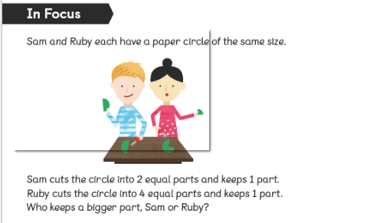  Compare the amount that is left on the table. Who has more in their hands? Why?  Which is greater ½ or 1/4? Why?  A ½ is equivalent to 2/4 so ½ is more than ¼.  Problem: Can I compare fractions?  See Worksheet 1 – You have two pages today.  Guided Practice:  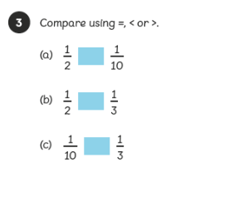 | Reading  - Read the pages 28-31 (See Monday reading worksheet) and answer the questions from worksheet 6.  Comprehension  Read the comprehension (See Worksheet –Comprehension – 1 page)  Answer the questions (See Worksheet Questions- 1 page).  Remember the steps to successfully answer each question confidently.  Read the text  Underline any words or phrases that I don’t understand.  Discuss these words with somebody.  Read each question carefully.  Read the text highlighting the evidence I can use in my answer.  Answer the question independently using a full sentence.  Class Novel  Click on the link to watch me read a story!  https://www.youtube.com/watch?v=67ArFs1wP50 | Science  Plants  This week, you will still be learning about plants.  Today, you will learn about plant growth.  https://www.bbc.co.uk/bitesize/topics/zy66fg8/articles/z98jpbk  Now, have a go at the plant growth worksheet
Tuesday | TTRS https://play.ttrockstars.com/auth/school/student  In Focus:  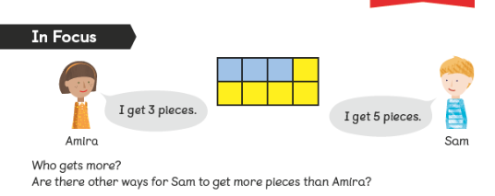  How many pieces are there altogether? What will the denominator be? Which number is greater: 3 or 5? Write these as a fraction?  There are 8 pieces altogether so the denominator is 8. Amira has 3 out of 8 so 3/8. Sam has 5 out of 8 so 5/8. 5 is greater than 3 so Sam has more.  Problem: Can I compare fractions?  See Worksheet 2 – You have two pages today.  Guided Practice:  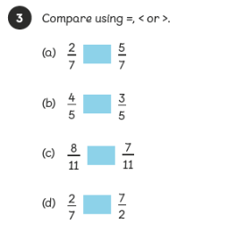 | Writing  This week, you will write a setting description and a character description. What is a setting? What is a character?  What may we use in our writing to make it interesting?  We will use adjectives, fronted adverbials, similes and powerful vocab!  Using the setting and character pictures, select a picture of each. (Use worksheet Setting and character) You can use your own character and setting if you wish!  Using the word mats, select a bank of adjectives, fronted adverbials, similes and powerful vocab that you can use in your writing.  Class Novel  Click on the link to watch me read a story!  https://www.youtube.com/watch?v=wxjnxGUN2sw | History  We are still looking at Ancient Greece. This week,  we will look at the Greek gods and goddesses  https://www.bbc.co.uk/bitesize/topics/z87tn39/articles/zgt7mp3  Can you pick a god or goddess and create a fact  File? Use the fact file template.
Wednesday | TTRS https://play.ttrockstars.com/auth/school/student  In Focus:  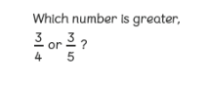  Think of a bar to help you. Which one is closer to a whole?  4/4 would be a whole so ¾ is ¼ away.  5/5 would be a whole so 3/5 is 2/5 away.  Which one is more?  Problem: Can I find compare fractions?  See Worksheet 3 – You have two pages today.  Guided Practice:  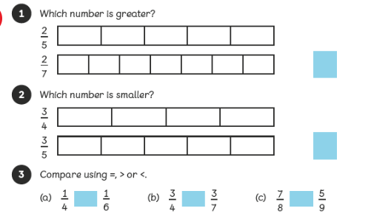 | Reading  Read the pages 32-35 (See Wednesday reading worksheet) and answer the questions from worksheet 7.  Writing  Today, you are going to write a description about your chosen setting. Use your bank of words from yesterday!  Use the videos to help  https://www.bbc.co.uk/bitesize/topics/zpccwmn/articles/z8mqsrd  https://www.bbc.co.uk/bitesize/topics/zkgcwmn/articles/zfh6vk7  https://www.bbc.co.uk/bitesize/clips/z2vpyrd  Class Novel  Click on the link to watch me read a story!  https://www.youtube.com/watch?v=gQNGaqWfR78 | Computing  Log into scratch using the username and  Password below and get creating!  Can you remember what an algorithm is?  Why do we use them?  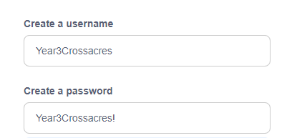  https://scratch.mit.edu/
Thursday | TTRS https://play.ttrockstars.com/auth/school/student  In Focus:  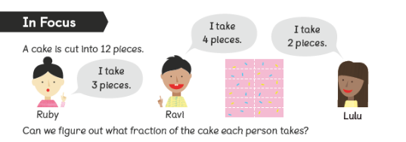  Write the amounts as fractions EG: Ruby’s is 3/12.How can we make this smaller? What can we divide 3 and 12 by? Now do the same for Ravi and Lulu. Who has more how do you know?  We can divide 3 and 12 by 3. = ¼ so 3/12 simplified is ¼.  Problem: Can I simplify fractions?  See Worksheet 4 – You have one page today.  Guided Practice:  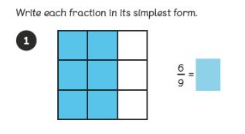 | Writing  Today, you are going to write a description about your chosen character. Use your bank of words from yesterday!  Use the videos to help  https://www.bbc.co.uk/bitesize/clips/z2vpyrd  https://www.bbc.co.uk/bitesize/topics/zkgcwmn/articles/zd72scw  https://www.bbc.co.uk/bitesize/topics/zfxtyrd/articles/z49hhbk  Class Novel  Click on the link to watch me read a story!  https://www.youtube.com/watch?v=jCEvmlJsIuo | PE  As well as exercising our brain, it is just important  That you exercise your body!  Take part in a Joe Wicks PE lesson!  Have fun!  https://www.youtube.com/watch?v=Y_SYhZ269HE
Friday | TTRS https://play.ttrockstars.com/auth/school/student  In Focus: 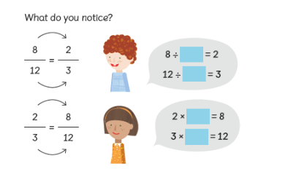  How would we get from 2 to 3? How would we get from 3 to 12?  Problem: Can I simplify fractions?  See Worksheet 5 – You have one page today.  Guided Practice:  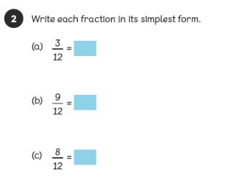 | Reading  Read the pages 36-40 (See Friday reading worksheet) and answer the questions from worksheet 8.  SPAG  Spelling:  Here are ten common exception words to learn how to spell.  group  guard  guide  heard  heart  height  history  imagine  increase  important  Punctuation:  Why do we use punctuation? Why are there so many different types of punctuation?  https://www.bbc.co.uk/bitesize/clips/zsh2tfr  Grammar:  There are four different types of sentences:  Command  Statement  Question  Exclamation  What are these types of sentences?  They need different types of punctuation! Do you know what they are?  Have a go at selecting the correct sentence:  https://uk.ixl.com/ela/year-3/is-the-sentence-a-statement-question-command-or-exclamation  Class Novel  Click on the link to watch me read a story!  https://www.youtube.com/watch?v=KAo9B-vPMDE | Art/DT  Have fun still designing your ancient Greek  temple!  Use the link below to research more about Ancient  Greece temples.  https://www.touropia.com/famous-greek-temples/

