Year Group: 3 Week beginning: 22.06.2020
Day | Maths Activities  Topic: Fractions | English Activities  Topic: Speech (story writing)  Shared Reading: The Jam Doughnut that ruined my life  Class Novel: The Vanishing of Billy Buckle | Other Subject Activities
Monday | TTRS https://play.ttrockstars.com/auth/school/student  This week, you will be finding equivalent fractions. What do you think equivalent means? What does equal? What do you think equivalent means now? Why?  Use the fraction wall to help you  In Focus:  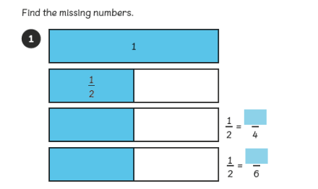  Notice how the bars are the same amount!  How may you get from 2 to 4 what may you times it by? What you times the 1 by? Why?  Equivalent fractions mean they are the same amount even though they look different. ½ is the same as 2/4. To change the numerator from 1 to 2 you times by 2 so then you must times the denominator by the same amount. So 2 times 2 = 4.  Problem: Can I find equivalent fractions?  See Worksheet 1 – You have one page today.  Guided Practice:  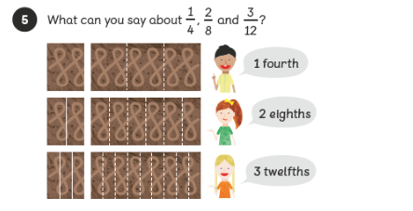 | Reading  - Read the pages 16-19 (See Monday reading worksheet) and answer the questions from worksheet 6.  Comprehension  Read the comprehension (See Worksheet –Comprehension – 1 page)  Answer the questions (See Worksheet Questions- 1 page).  Remember the steps to successfully answer each question confidently.  Read the text  Underline any words or phrases that I don’t understand.  Discuss these words with somebody.  Read each question carefully.  Read the text highlighting the evidence I can use in my answer.  Answer the question independently using a full sentence.  Class Novel  Click on the link to watch me read a story!  https://www.youtube.com/watch?v=c65nyPK43OE | Science  Plants  This week, you will still be learning about plants.  Today, you will learning why bees are attracted  to plants? Why do you think this is?  https://www.bbc.co.uk/bitesize/topics/zy66fg8/articles/zx4ktv4  Now, have a go at the pollination worksheet.
Tuesday | TTRS https://play.ttrockstars.com/auth/school/student  In Focus:  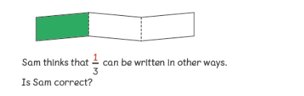  If I was to times 1 by 2 what would I get? What do I need to do now? Why?  Can I times 1 by any other number? What will I need to do now? Why?  Use the fraction wall to help you  If you times 1 by 2 then you get 2. You should now times 3 by 2 to get 6. So 1/3 is equivalent to 2/6.  Problem: Can I find equivalent fractions?  See Worksheet 2 – You have one page today.  Guided Practice:  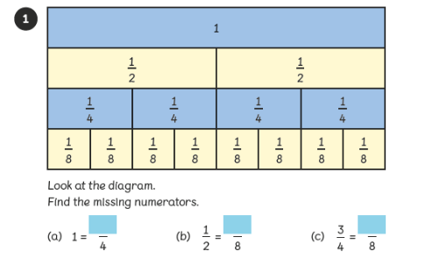 | Writing  This week, we will recap speech.  Why do we use speech in our writing?  Can you remember the rules of speech?  Speech must be punctuated correctly.  https://www.bbc.co.uk/bitesize/clips/zvftsbk  Now have a go at punctuating speech worksheet  Class Novel  Click on the link to watch me read a story!  https://www.youtube.com/watch?v=0KRU51_aIBI | Geography  We are still looking at Ancient Greece. This week,  we will look at rivers in Greece.  https://kids.kiddle.co/List_of_rivers_of_Greece  https://www.mapsofworld.com/greece/greece-river-map.html  Can you pick a river and research it?  Where does it run through?  How long is it?  Are there any activities held on the river?  Is it home to any animals?
Wednesday | TTRS https://play.ttrockstars.com/auth/school/student  Use the fraction wall to help you  In Focus:  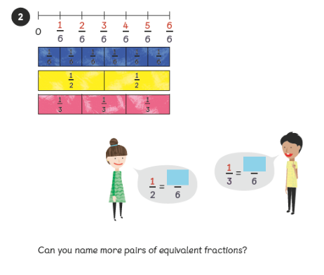  What would we times the numerator by? Why?  Remember whatever you times the denominator by, you must times the numerator by the same amount.  Problem: Can I find equivalent fractions?  See Worksheet 3 – You have one page today.  Guided Practice:  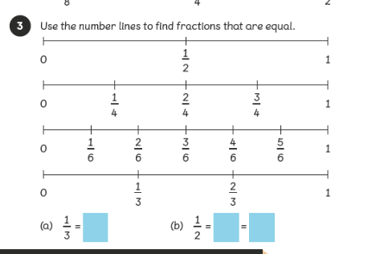 | Reading  Read the pages 20-23 Wednesday read-ng worksheet) and answer the questions from worksheet 7.  Writing  Today, you are going to have a go at writing some speech.  https://www.bbc.co.uk/bitesize/topics/zr6bxyc/articles/zhqh92p  Now have a go at writing your own speech.  To help:  Use the said synonyms sheet  Use the inverted commas sheet  Class Novel  Click on the link to watch me read a story!  https://www.youtube.com/watch?v=Gbi9DFjLi58 | PSHE  Staying positive is a key skill to help you  remain calm, happy and healthy.  Although we are currently going through a tricky  time, it is important to stay positive.  Complete the PSHE worksheet to help you stay  positive.
Thursday | TTRS https://play.ttrockstars.com/auth/school/student  In Focus:  Use the fraction wall to help you  Remember the rules!  Problem: Can I find equivalent fractions?  See Worksheet 4 – You have one page today.  Guided Practice:  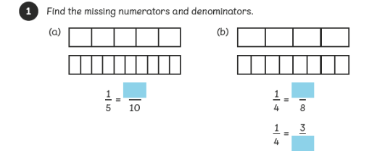 | Writing  Today, have a go at writing some more speech. Can you challenge yourself and use split speech?  https://english.stackexchange.com/questions/421389/how-to-break-direct-speech-into-two-parts-right  Now have a go at using split speech.  To help:  Use the said synonyms sheet  Use the inverted commas sheet  Class Novel  Click on the link to watch me read a story!  https://www.youtube.com/watch?v=m_MEkp4sPIs | PE  As well as exercising our brain, it is just important  That you exercise your body!  Take part in a Joe Wicks PE lesson!  Have fun!  https://www.youtube.com/watch?v=XwD23OPFnwE
Friday | TTRS https://play.ttrockstars.com/auth/school/student  In Focus:  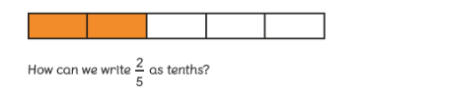  Use the fraction wall to help you  How would we get from 5 to 10? What do we need to do now? Why?  Problem: Can I find equivalent fractions?  See Worksheet 5 – You have one page today.  Guided Practice:  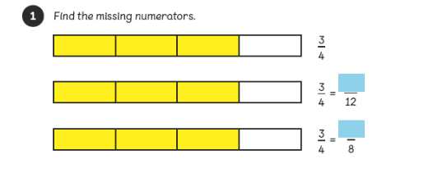 | Reading  Read the pages 24-27 Friday reading worksheet) and answer the questions from worksheet 8.  SPAG  Spelling:  Here are ten common exception words to learn how to spell.  exercise  extreme  experience  famous  favourite  February  forward  forwards  fruit  grammar  Punctuation:  Can you punctuate the sentences correctly? Remember to think about what type of sentence it is to help you determine what punctuation it needs.  See punctuate sentences worksheet  Grammar:  Adjectives describe a noun. They tell us what kind of something or how many. Can you identify which?  https://uk.ixl.com/ela/year-3/does-the-adjective-tell-you-what-kind-or-how-many  Class Novel  Click on the link to watch me read a story!  https://www.youtube.com/watch?v=jiGEfuv1Zoo | Art/DT  This week and next you are going to design an  Ancient Greece temple. You will need to think  about the materials you will need and how it may  aook.  Use the link below to research more about Ancient  Greece temples.  https://www.touropia.com/famous-greek-temples/

