Year Group: 3 Week beginning: 15.06.2020
Day | Maths Activities  Topic: Fractions | English Activities  Topic: Explanation Text  Shared Reading: The Jam Doughnut that ruined my life  Class Novel: Fing | Other Subject Activities
Monday | TTRS https://play.ttrockstars.com/auth/school/student  Today and tomorrow, you will be adding fractions. If we are adding, will the amount get bigger or smaller? Why? How do you know? What symbol do we use when adding?  In Focus:  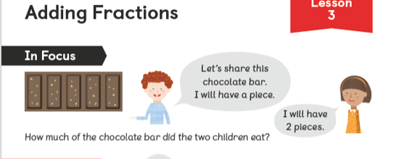  What will the calculation be? Don’t forget we are adding fractions how many pieces are there in total? This will be the denominator. How do we say this as a fraction? How many pieces does each child eat? This will be the numerator.  There are 5 pieces of chocolate so the denominator will be /5. We call these fifths. If you ate 3 pieces the numerator will be 3. Therefore, you have eaten 3 out of 5 pieces. As a fraction it will look like 3/5. If I ate 1 piece the numerator will be 1/5. The calculation will look like 3/5 + 1/5 = 4/5. 4 out of the 5 pieces have been eaten.  Problem: Can I add fractions?  See Worksheet 1 – You have one page today.  Guided Practice:  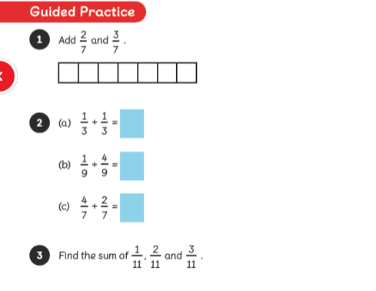 | Reading  - Read the pages 7-9 (See Monday reading worksheet) and answer the questions from worksheet 6.  Comprehension  Read the comprehension (See Worksheet –Comprehension – 2 pages)  Answer the questions (See Worksheet Questions- 1 page).  Remember the steps to successfully answer each question confidently.  Read the text  Underline any words or phrases that I don’t understand.  Discuss these words with somebody.  Read each question carefully.  Read the text highlighting the evidence I can use in my answer.  Answer the question independently using a full sentence.  Class Novel  Click on the link to watch me read a story!  https://www.youtube.com/watch?v=9ofgY-HyLl4&t=237s | Science  Plants  This week, you will still be learning about plants.  Today, you will look at the parts of a plant. Take  a look at your sketch of your plant/flower that  you drew last week. What parts can you see? Do  you know any of the names?  Have a look at the link below to find out abut the  parts of a plant:  http://flash.topmarks.co.uk/3334  Now complete the worksheet parts of a plant.
Tuesday | TTRS https://play.ttrockstars.com/auth/school/student  In Focus:  What will the calculation be? Don’t forget we are adding fractions how many pieces are there in total? This will be the denominator. Will the denominator be different today? Why? How do you know? How many pieces does each child eat? This will be the numerator.  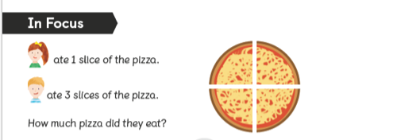  There are 4 pieces of pizza so the denominator will be /4. How do we say this as a fraction? Do we say 4ths? The calculation will look like 1/4 + 3/4 = 4/4. 4 out of the 4 pieces have been eaten. What do you notice now? How else can we write this as a fraction? Why?  Problem: Can I add fractions?  See Worksheet 2 – You have one page today.  Guided Practice:  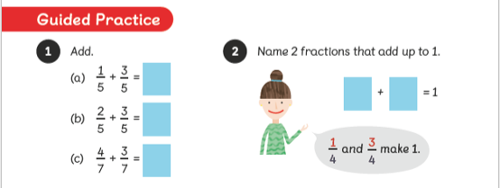 | Writing  Last week, you wrote an explanation text on how plants live. This week, you are going to write an explanation text on how to care for an animal of your choice.  Ideas: Cat, dog, fish, elephant, tiger, dinosaur, hamster, pig, parrot.  Task: Using the I-Pads, research as much information as you can about your chosen animal.  Use the comprehension from Monday to help you with ideas on what to research.  Class Novel  Click on the link to watch me read a story!  https://www.youtube.com/watch?v=oVR-YpYp4pM&t=5s | History  We are still looking at Ancient Greece. I wonder  what it was like to live in Ancient Greece times?  Watch the link below to find out.  https://www.bbc.co.uk/bitesize  /topics/z87tn39/articles/zc8yb9q  How does it compare to life today? Is anything  the same? Is anything different? Why?  What would you prefer? Why?  Now complete worksheet similarities and different:  What is the same and what is different? Then,  Write what you would prefer and why.
Wednesday | TTRS https://play.ttrockstars.com/auth/school/student  Now, you will be subtracting fractions. If we are subtracting, will the amount get bigger or smaller? Why? How do you know? What symbol do we use when subtracting?  In Focus:  What will the calculation be? Don’t forget we are subtracting fractions how many pieces were there in total? This will be the denominator. Will the denominator be different today? Why? How do you know? How many pieces have been eaten? How many pieces will be left? This will be the numerator.  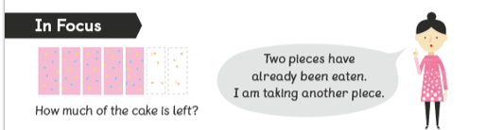  There were 7 pieces of the cake altogether – this will be the denominator /7. 2 pieces of cake had been eaten plus 1 more so this is 3 pieces of cake that had been eaten. The calculation will be 7/7 – 3/7 = 4/7.  Problem: Can I subtract fractions?  See Worksheet 3 – You have one page today.  Guided Practice:  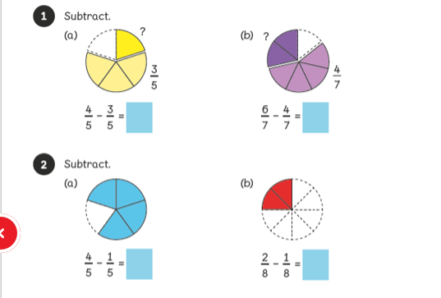 | Reading  Read the pages 10-12 (See Wednesday reading worksheet) and answer the questions from worksheet 7.  Writing  Today, you are going to put all the information you have researched into categories. Use the subheadings:  Habitat, Diet, Behaviour, Dangers, Did you know?  Once you have done that, you can start writing your explanation text. (Template to support if needed)  Don’t forget to use:  Subheadings  Fronted adverbials (worksheet to support)  Adjectives (worksheet to support)  Conjunctions (worksheet to support)  Paragraphs  Does it matter what order you write it in?  Class Novel  Click on the link to watch me read a story!  https://www.youtube.com/watch?v=kqV8JzGB-ps | Computing  Now that we are spending a lot more time indoors,  you may be playing a lot more games online.  So it is very important that you remember to  be safe!  Can you remember how we stay safe online?  Make a poster to remind yourself and others how  to stay safe.  Use this link to help you  https://www.bbc.co.uk/cbbc  /findoutmore/help-me-out-staying-safe-online
Thursday | TTRS https://play.ttrockstars.com/auth/school/student  In Focus:  Can you help Elliot solve this problem?  What are starting with now? We are not starting with the whole amount! How many are shaded to begin with?  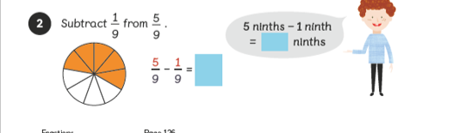  5/9 was shaded to begin with. Elliot took 1/9 away. What will the calculation look like?  Problem: Can I subtract fractions?  See Worksheet 4 – You have one page today.  Use the bars to help you work out each calculation. Remember to look at the amount you are starting with. If it is 3/6, shade 3 out of the 6 ready. Then subtract the amount it is saying.  Guided Practice:  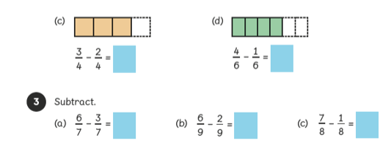 | Writing  Today, you can finish writing your explanation text. (Template to support if needed)  Don’t forget to use:  Subheadings  Fronted adverbials (worksheet to support)  Adjectives (worksheet to support)  Conjunctions (worksheet to support)  Paragraphs  Does it matter what order you write it in?  Class Novel  Click on the link to watch me read a story!  https://www.youtube.com/watch?v=mXLHG2qwd_Y | RE  Each religion has their own symbol and sign  that represents something special within their  religion.  Can you research what the symbols are for the  following religions?  Buddhism Christianity Judaism  Hinduism Sikhism  Draw these symbols on a piece of paper labelling  them correctly.
Friday | TTRS https://play.ttrockstars.com/auth/school/student  In Focus:  How many cupcakes are there to start with?  How many are left after 5 are eaten? How would we write this as a fraction?  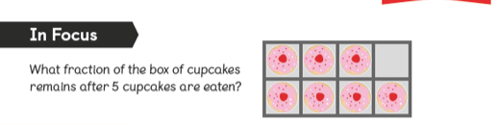  There is 7/8 to start with and 5/8 are left. What would the calculation be?  Problem: Can I subtract fractions?  See Worksheet 5 – You have one page today.  Guided Practice:  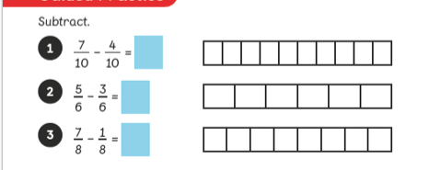 | Reading  Read the pages 13-15 (See Friday reading worksheet) and answer the questions from worksheet 8.  SPAG  Spelling:  Here are ten common exception words to learn how to spell.  decide  describe  different  difficult  disappear  early  earth  eight  eighth  enough  Punctuation:  Can you punctuate my paragraph that I have written? What is punctuation? Why do we use it?  See worksheet punctuation.  Grammar:  Using the correct article. Remember articles are a or an. They are a determiner and they come before a noun.  We use the article an before any nouns beginning with a vowel (a,e,i,o,u).  We use the article a before any nouns beginning with any other letter, a consonant.  Use this link to test your knowledge! https://uk.ixl.com/ela/year-3/use-the-correct-article-a-or-an  Class Novel  Click on the link to watch me read a story!  https://www.youtube.com/watch?v=FF5SaOW0scI | Art/DT  The Ancient Greeks used a form of mosaics for  Their art designs.  Use the link below to research more about mosaics.  https://kids.kiddle.co/Mosaic  Can you design your own?  Use the mosaic template to help you.

