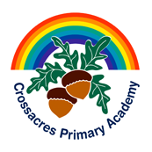 Year Group: 3 Week beginning: 13.07.20
Day | Maths Activities  Topic: Fractions | English Activities  Topic: Story writing  Shared Reading: The Jam Doughnut that ruined my life  Class Novel: Fing | Other Subject Activities
Monday | TTRS https://play.ttrockstars.com/auth/school/student  This week, you will be solving work problems for three days and then complete a fractions review on what you know for 2 days. Don’t let this worry you! Use your knowledge of fractions to help you. Read the question carefully, solve the problem and answer in a full sentence. The review will help you consolidate what you have already learnt.  In Focus:  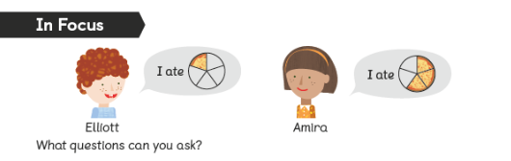  Looking at the picture what questions could we ask?  Looking at the fraction amounts, what could we ask?  There are two people – Elliot and Amira. We could say who ate more/less?  The fractions are in fifths. We could say how much did they eat altogether?  Problem: Can I solve word problems?  See Worksheet 1 – You have one page today.  Guided Practice:  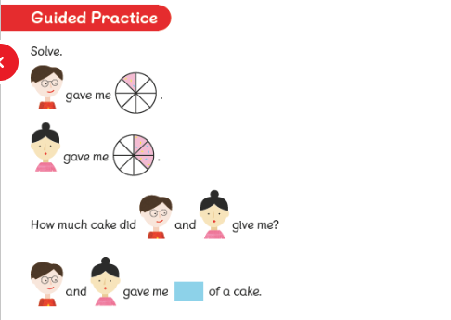 | Reading  - Read the pages 50-52 (See Monday reading worksheet) and answer the questions from worksheet 6.  Comprehension  Read the comprehension (See Worksheet –Comprehension – 1 page)  Answer the questions (See Worksheet Questions- 1 page).  Remember the steps to successfully answer each question confidently.  Read the text  Underline any words or phrases that I don’t understand.  Discuss these words with somebody.  Read each question carefully.  Read the text highlighting the evidence I can use in my answer.  Answer the question independently using a full sentence.  Class Novel  Click on the link to watch me read a story!  https://www.youtube.com/watch?v=g-GEHz4MJRI | Science  Plants  This week, you will still be learning about plants.  Today, you will look at the life cycle of a plant.  Use this video to help you.  https://www.bbc.co.uk/bitesize/clips/zgqyrdm  Now, complete the three worksheets (science 1,2  And 3)  There is then a game you can play (science4)
Tuesday | TTRS https://play.ttrockstars.com/auth/school/student  In Focus:  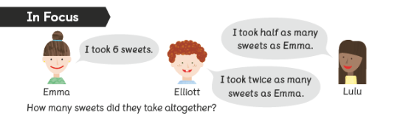  What does altogether mean? How may we solve this?  Where would we start – what do we know?  We would start with Emma – she has 6 sweets.  Now work your way from here – Lulu has half of 6 and Elliott has double 6.  To find the total altogether you would add.  Problem: Can I solve word problems?  See Worksheet 2 – You have one page today.  Guided Practice:  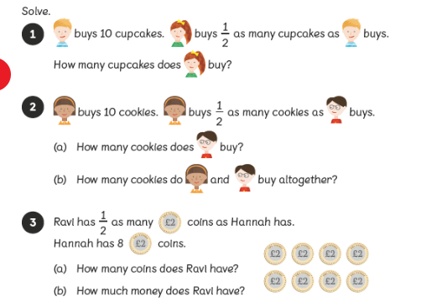 | Writing  This week, you will continue to write an adventure story  Today, you will write the resolution of your story.  Use your plan and word mats to help you.  Use the link below to help too!  https://www.bbc.co.uk/bitesize/topics/zpccwmn  Class Novel  Click on the link to watch me read a story!  https://www.youtube.com/watch?v=Mw9j8N_FLis | History  This week, you will red up on how the Ancient  Greeks were always at war!  https://www.bbc.co.uk/bitesize/topics/z87tn39/articles/zckr4wx  Can you write a letter to the Spartan army to help  You fight the Persians?  See letter template to help you.
Wednesday | TTRS https://play.ttrockstars.com/auth/school/student  In Focus: 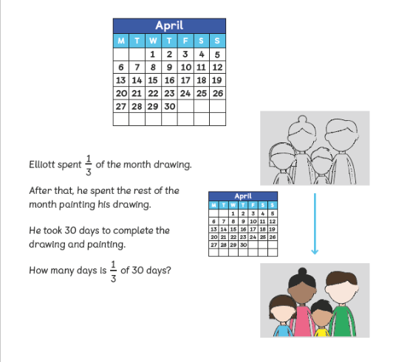  What fractions are we working with? What calculation do we need to do?  We will need to find a fraction of an amount.  Problem: Can I solve word problems?  See Worksheet 3 – You have one page today.  Guided Practice:  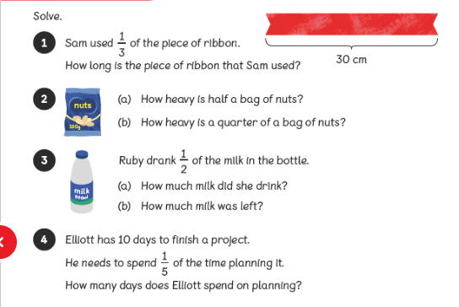 | Reading  Read the pages 53-55 (See Wednesday reading worksheet) and answer the questions from worksheet 7.  Writing  Today, you are going to write the ending of your story.  Use your plan and word mats to help you.  Use the link below to help too!  https://www.bbc.co.uk/bitesize/topics/zpccwmn  Class Novel  Click on the link to watch me read a story!  https://www.youtube.com/watch?v=r5MJNjMx_iw | PSHE  As we reach the end of year 3, we may have some  worries and concerns, which is extremely normal.  Even more so with how strange this year has been.  It is okay to say how you feel and talk about  Anything that worries you.  Fill in the worries worksheet and talk them through  With an adult.
Thursday | TTRS https://play.ttrockstars.com/auth/school/student  In Focus:  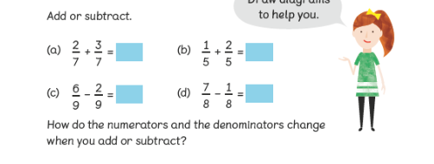  Think about how you completed these calculations previously.  Problem: Can I review my work?  See Worksheet 4 – You have two pages today. | Writing  Today, you are going to edit your story and redraft it. Can you make it better? Can you up level your vocabulary and check your spellings?  Use the link below to help you.  https://www.bbc.co.uk/bitesize/articles/zryxt39  Class Novel  Click on the link to watch me read a story!  https://www.youtube.com/watch?v=Q5aCDKf1WVs | PE  As well as exercising our brain, it is just important  That you exercise your body!  Take part in a Joe Wicks PE lesson!  Have fun!  https://www.youtube.com/watch?v=MFAT6PUfYPM
Friday | TTRS https://play.ttrockstars.com/auth/school/student  In Focus:  No in focus today  Problem: Can I review my work?  See Worksheet 5 – You have three pages today. | Reading  Read the pages 56 (See Friday reading worksheet) and answer the questions from worksheet 8.  SPAG  Spelling:  Here are ten common exception words to learn how to spell.  natural  naughty  notice  occasion  occasionally  often  opposite  ordinary  particular  peculiar  Punctuation:  Pick a punctuation game!  https://www.teachwire.net/news/6-of-the-best-online-punctuation-games-for-spag-ks2-english  Grammar:  What are pronouns?  Why do we use them?  Let’s see what you know!  https://uk.ixl.com/ela/year-3/identify-personal-pronouns  Class Novel  Click on the link to watch me read a story!  https://www.youtube.com/watch?v=GkeKEFlKEpg | Art/DT  This week, you will draw or paint a picture for  Somebody in your class to say thanks for being  A great friend in year 3!

