Year Group: 3 Week beginning: 01.06.2020
Day | Maths Activities  Topic: Fractions | English Activities  Topic: Diary entry | Other Subject Activities
Monday | Teacher Training
Tuesday | Teacher Training
Wednesday | TTRS https://play.ttrockstars.com/auth/school/student  In Focus:  What is a fraction?  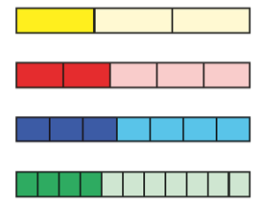  This is 1/3  Problem: Can I understand what a fraction is?  https://www.bbc.co.uk/bitesize/articles/zd8mt39 | Reading  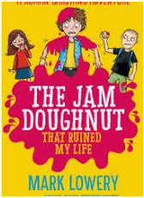  Prediction: What do you think this book is about? Why do you think that?  Let’s read the blurb: ‘My name’s Roman Garstang and my life was completely ruined by a single doughnut. Take one jam doughnut, one flying jelly fish and one class lunatic and what do you get? Just another disastrous week in the life of Roman Garstang!’  Has your opinion changed? Why?  What word tells you that Roman’s life isn’t so great? | Science  States of Matter  What are states of matter?  https://www.bbc.co.uk/bitesize  /articles/z6j2mfr  Can you find out about their particles?  Key words: solid, liquid and gas.
Thursday | TTRS https://play.ttrockstars.com/auth/school/student  In Focus: Identifying a fraction. Can you identify what is shaded out of how many?  Problem: Can I identify the fraction shaded?  https://www.bbc.co.uk/bitesize/articles/zkmg47h | Writing  Roman’s life isn’t so great. I’m guessing if he were to write a diary entry about his day it would be full of awful things happening to him.  Can you remember what a diary entry is and what the features are?  https://www.bbc.co.uk/bitesize/articles/z6yxt39  Task: Can I write a diary entry?  It can either be based on a day in Roman’s life (make it up)  It can be about your day (you can make this as disastrous as you like)  It can be one of the activities on the link above. | History  Ancient Greece  Who were the Ancient Greeks?  https://www.bbc.co.uk/  bitesize/topics/z87tn39/articles  /zxytpv4  Can you write a fact file about the ancient greeks?
Friday | TTRS https://play.ttrockstars.com/auth/school/student  In Focus: Counting in tenths: How many tenths is this chocolate bar split into?  Can you count in tenths?  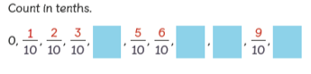  Problem: Can I count in tenths?  https://www.bbc.co.uk/bitesize/articles/zmcny9q | SPAG  Spelling:  accident  accidentally  actual  actually  address  answer  appear  arrive  believe  bicycle  Punctuation:  https://www.topmarks.co.uk/Flash.aspx?e=spelling-grammar05  Grammar:  https://uk.ixl.com/ela/year-3/is-the-sentence-in-the-past-present-or-future-tense | Art/DT  Can you draw or make an Ancient Greek building?  