Planning Week beginning: 6.4.20
 | Monday | Tuesday | Wednesday | Thursday | Friday
9.00- 9.30 | Listen to your child read aloud
9.00- 9.30 | Joe Wicks-KS2 upstairs /EYFS/KS1 hall.  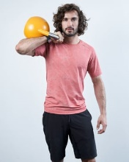 | Joe Wicks-KS2 upstairs /EYFS/KS1 hall. | Joe Wicks-KS2 upstairs /EYFS/KS1 hall. | Joe Wicks-KS2 upstairs /EYFS/KS1 hall. | Joe Wicks-KS2 upstairs /EYFS/KS1 hall.
9.30-10.30 | Reading/ Phonic/ Maths /Science  CGP books for EYFS/KS1/KS2  Also for KS2-  TT Rocks Stars  Year 6- https://uk.ixl.com/ | Reading/ Phonic/ Maths /Science  CGP books for EYFS/KS1/KS2  Also for KS2-  TT Rocks Stars  Year 6- https://uk.ixl.com/ | Reading/ Phonic/ Maths /Science  CGP books for EYFS/KS1/KS2  Also for KS2-  TT Rocks Stars  Year 6- https://uk.ixl.com/ | Reading/ Phonic/ Maths /Science  CGP books for EYFS/KS1/KS2  Also for KS2-  TT Rocks Stars  Year 6- https://uk.ixl.com/ | Reading/ Phonic/ Maths /Science  CGP books for EYFS/KS1/KS2  Also for KS2-  TT Rocks Stars  Year 6- https://uk.ixl.com/
10.30-10.45 | Break
10.45-11.45 | Project based learning | Project based learning | Project based learning | Project based learning | Project based learning
11.45-12.00 | Story / Novel
12.00- 1.15 | Lunch
1.15 -1.45 | Outdoor activities  Den building/ Team games  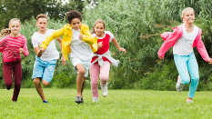 | Outdoor activities  Den building/ Team games  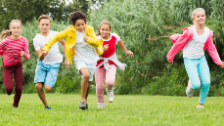 | Outdoor activities  Den building/ Team games  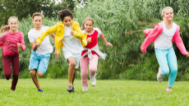 | Outdoor activities  Den building/ Team games  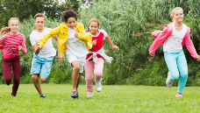 | Golden Time
1.45- 2.45 | Project based learning | Project based learning | Project based learning | Project based learning
2.45 -3.15 | Story / Novel
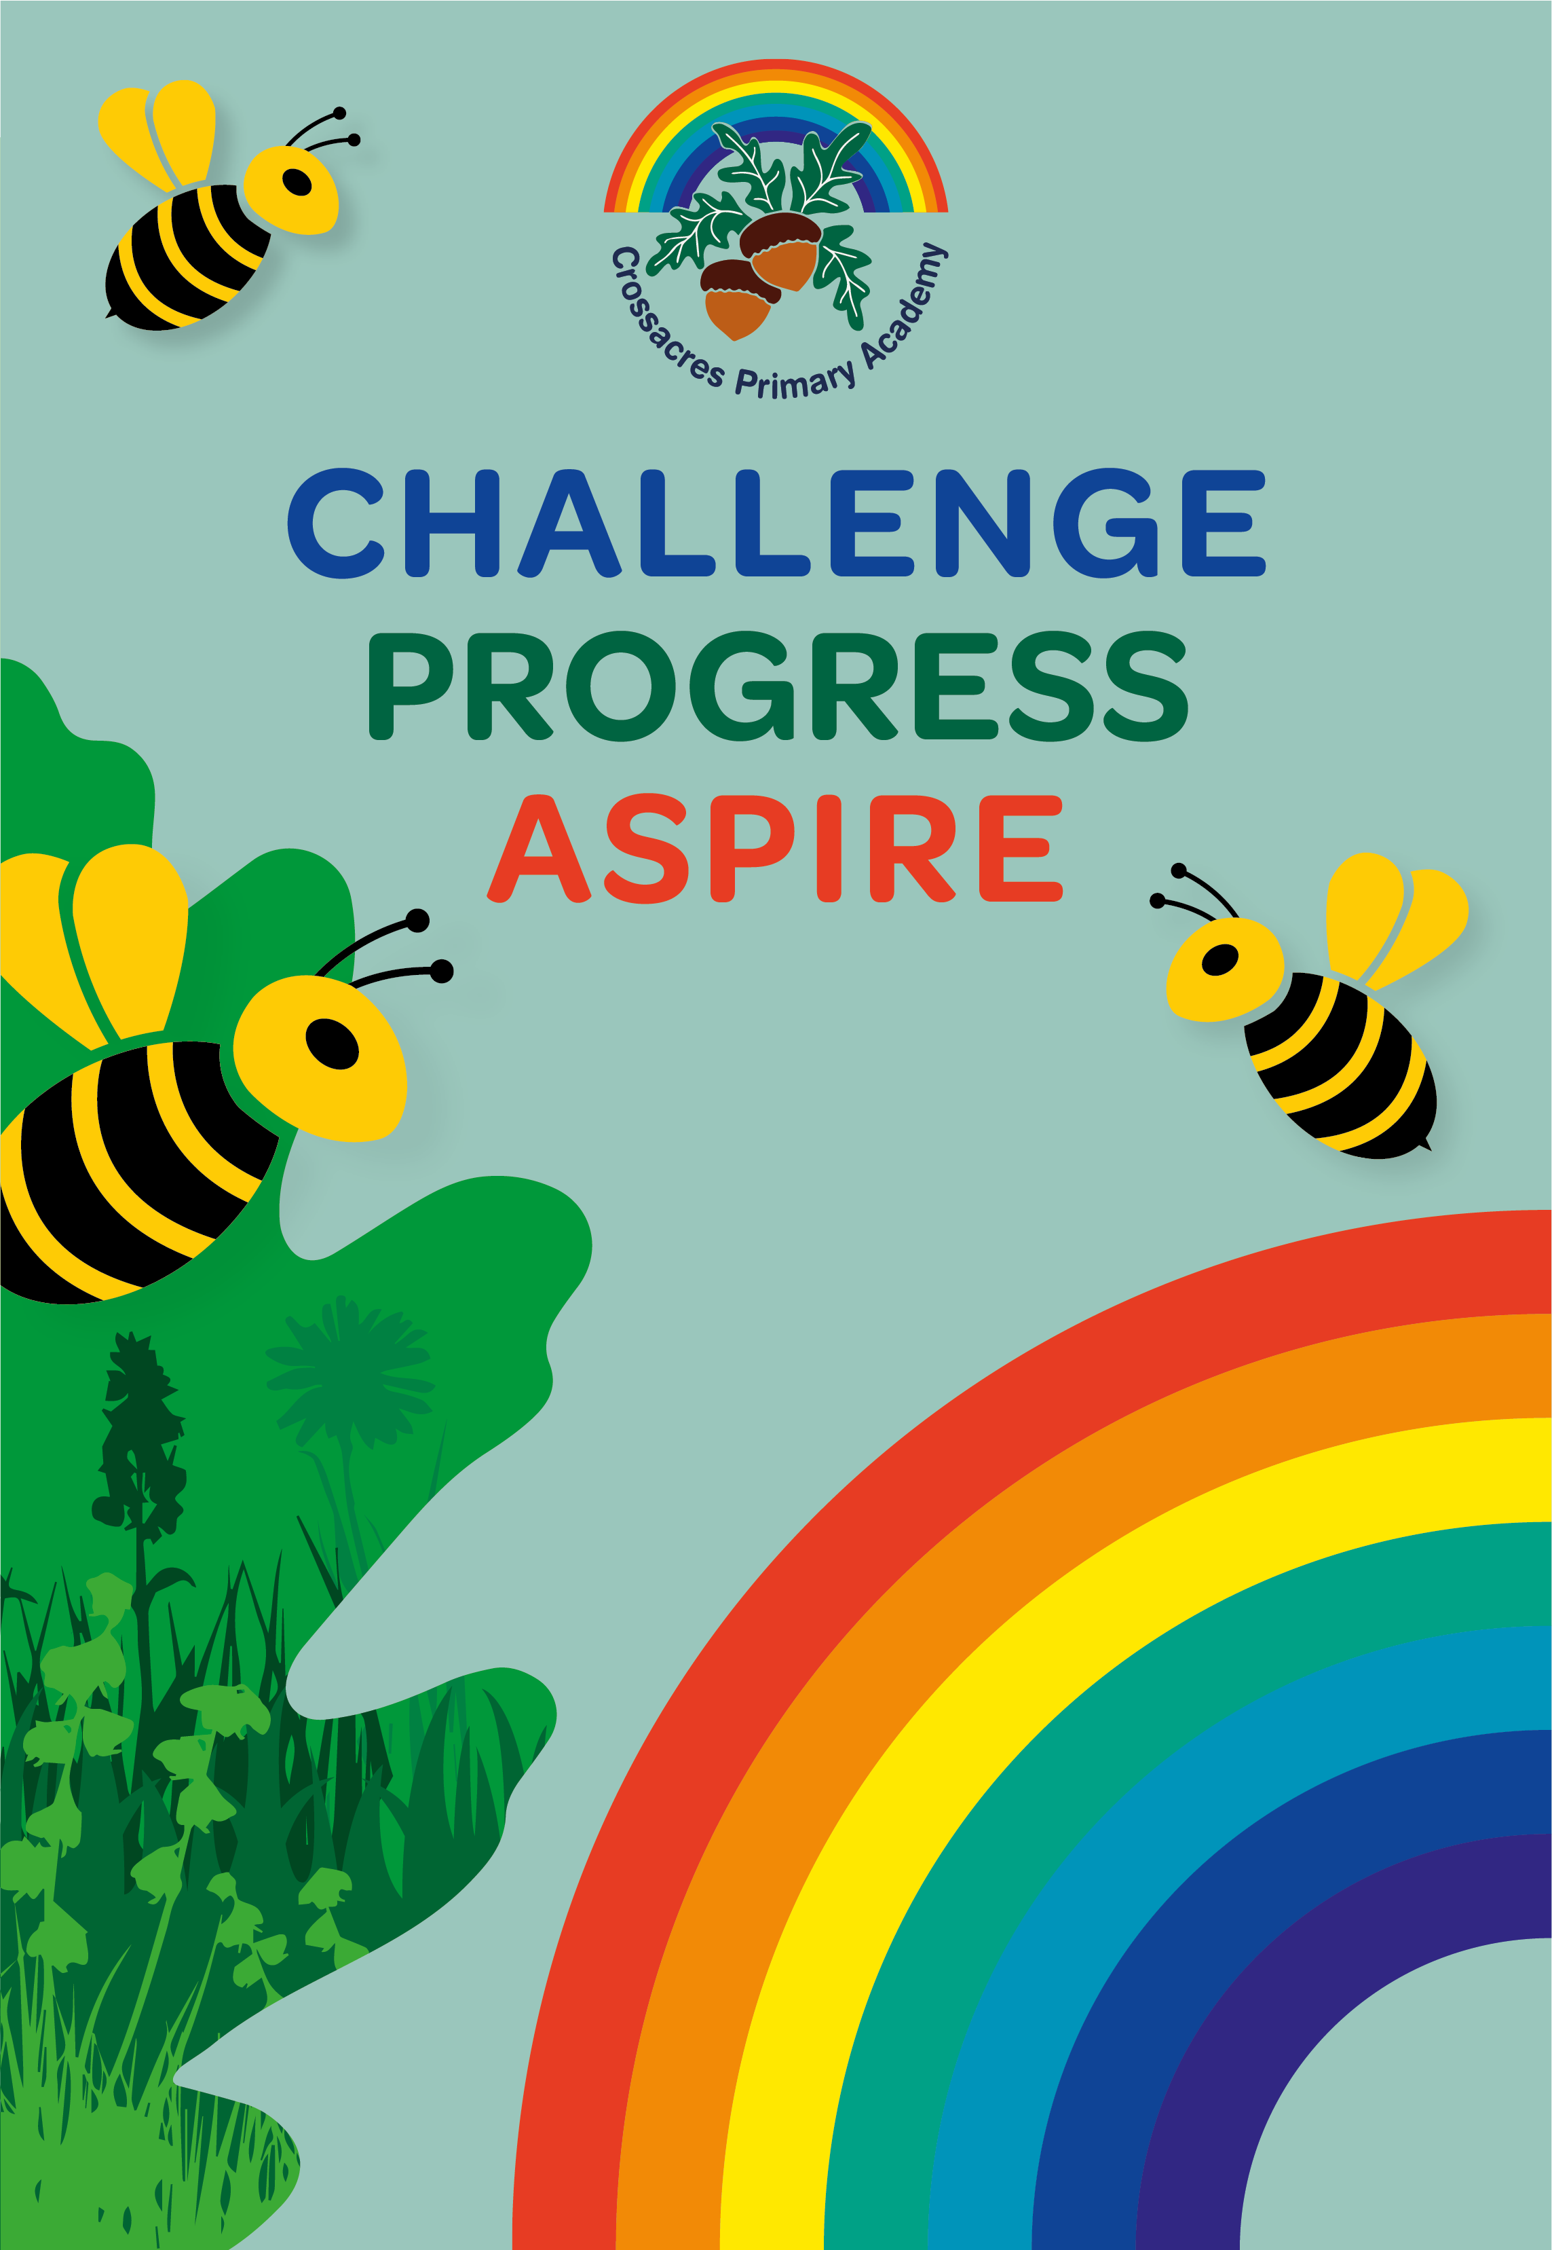
Project Based Learning – Under the Sea!
 | EYFS / KS1 | KS2
Monday  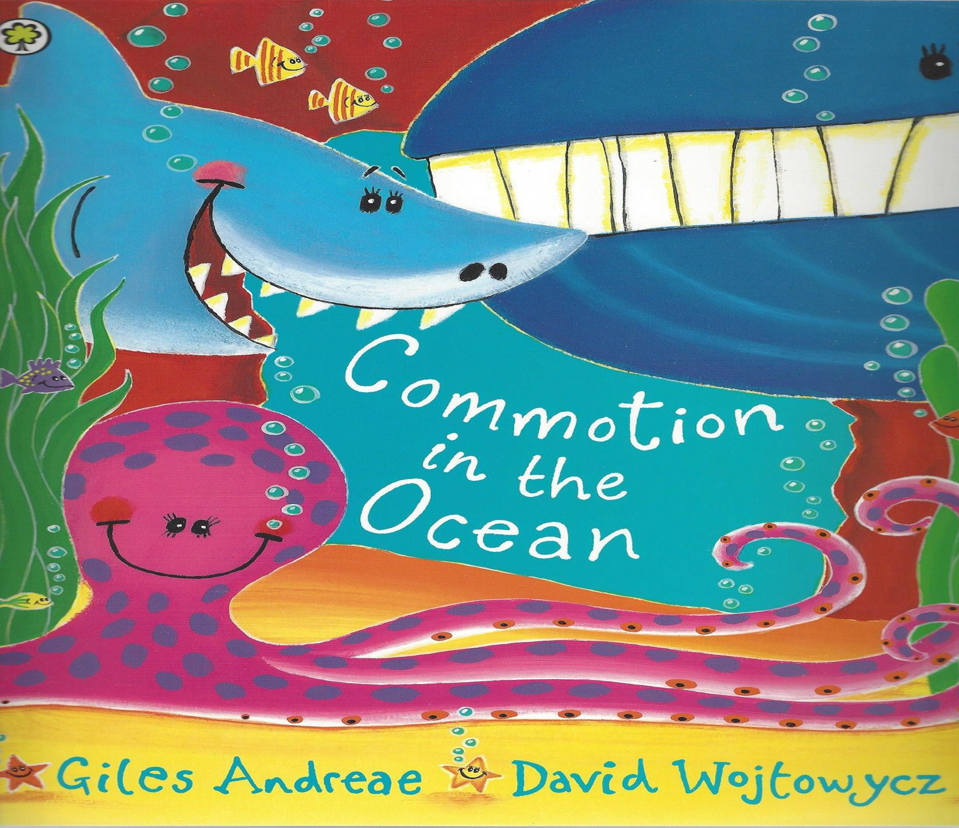 | Looking at Creatures Under the Sea.  - Share the story Commotion in the Ocean: https://www.youtube.com/watch?v=9pRhgZ8Jffs  - Identify the rhyme in the story.  - Children can draw and label all the creatures that are in the book.  - Children to sequence pictures from the book (see resources) in the order they appear. | Exploring Life Under the Sea  - Children to watch Blue Planet ll- Oceans of Wonder. https://www.bbc.co.uk/iplayer/episode/b09l2fgr/blue-planet-ii-oceans-of-wonder  - Make a list of all the different creatures under the sea.  - Explain that children will be picking one creature to research and create a fact file on. Start front cover/blurb etc.  - Each day children will create a page for their information book.
Tuesday | Labelling a fish/ shark/ Interesting facts  - https://www.youtube.com/watch?v=u_Xv5BRnflA watch this short video and discuss which types of fish we saw.  - Look at picture of a fish and label the different parts of a fish. Play I spy with different parts of a fish (See this video https://www.youtube.com/watch?v=yjlwt4J8Pg4|)  - Extension: children write some sentences about interesting facts about fish from video. | Introduction/ Contents Page  - Children write an introduction for their information text. Including a labelled diagram. What is special about the chosen animal/creature?  - Create a contents page.  - Include information which seas they live in and why that is?  - Is the species endangered?
Wednesday | Guess Who? Using adjectives  - As a class remind chn of the animals in commotion in the Ocean and play guess who. “I am large, blue, with very sharp teeth?”  - Children then write their own guess who or record on iPad for their friends to listen to. | Diet and Habitat  - Children research the diet and habitat of their chosen underwater creature.  - Use diagrams and real life photos within their writing.  - Look at food chains under the sea- (See resources for Power Point)  - Can children identify their chosen sea creature within a food chain?
Thursday  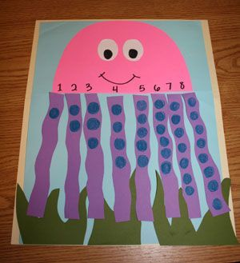 | Making an Octopus – Number bonds to 10  - Watch video of an Octopus- move around the classroom like an octopus. Look at how the octopus moves, changes colour and what body parts they have. https://www.youtube.com/watch?v=ydrc489USbM  - Look at picture opposite. Children can make an octopus showing number bonds to 10 or 1:1 correspondence.  - Look at different photos of octopuses and children draw and label. Extend with a sentence about octopuses. | Danger/ Threats and Predators!  - Children continue information texts. Children research the biggest dangers facing their chosen animal.  - Discuss the impact plastic is having in our seas.  - Recap Blue Planet and make notes on how this is affecting the seas.
Friday | Under the Sea –Fish Habitats  - Ask the children what does a fish home look like? What does it need? Ie; seaweed for protection from predators, food.  - Watch video of under the sea https://www.youtube.com/watch?v=UQRDv3HtmUA  - Children to design and draw their own underwater scene.  - Create a large underwater scene with all the creatures from Commotion in the Ocean. Get the children to draw/make/paint all the different fish, shark, turtles etc. (see picture below) | Coral Reef  - https://www.youtube.com/watch?v=ZiULxLLP32s Watch information video about Coral Reef.  - Children complete Reading comprehension about the coral reef. (In resources folder)  - Extension: Crack the code – underwater theme, in resources.

Craft Ideas
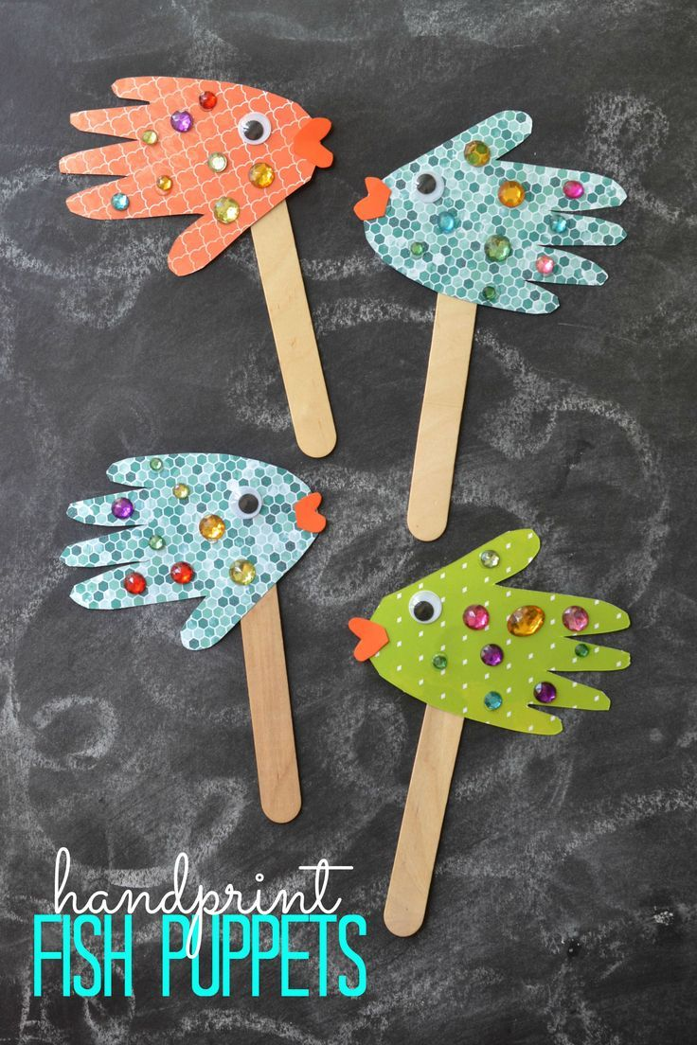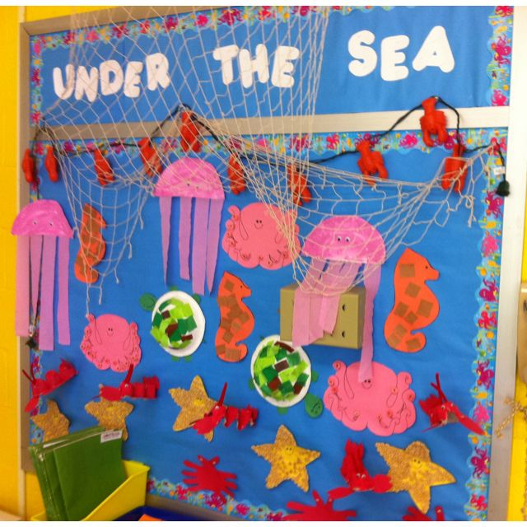

Easter Activities
EASTER
 | EYFS / KS1 | KS2
Friday | - Children are shown PowerPoint about the Easter Story.  - Using template children order the events of the Easter week.  - Make a mind map of all the different ways we celebrate Easter. | - https://www.youtube.com/watch?v=Wnbo2AmS3OI&feature=emb_title  - This video is from the BBC explaining why Christians celebrate Easter and some of the traditions.  - Explain to children what happened at the Last Supper. Children could write in role as a disciple at the Last supper, detailing the events.
Monday | Fun Easter Activities:  - Children can design an egg.  - Make Easter cards.  - Cutting activity on twinkl of Easter bunnies.  - Baking- making chocolate nests for chicks. | Sequence the Events of the Easter Story  - Children to create their own comic strip, detailing the events of the Easter story.  - Children can make Easter cards.
Easter Egg Hunt
As requested, teachers set up an Easter Egg hunt around the playground. 