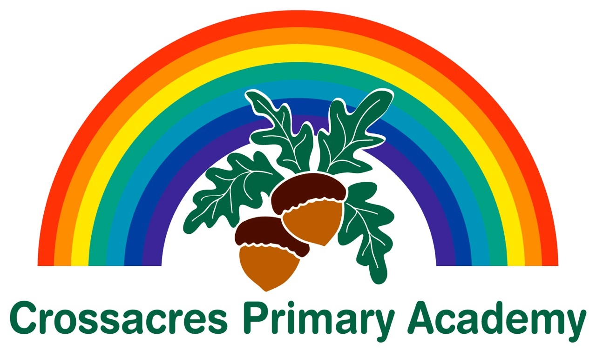

Uniform Order Form

To avoid disappointment, please order your uniform as soon as possible.
Please note: It may take up to 6 weeks for orders to arrive.

Sweatshirts 24” – 34” - £9.00
XS, S, (adult sizes) - £10.50
Sweat cardigans 24” – 34” - £10.00
XS, S (adult sizes) - £11.00
Fleeces 3/4, 5/6, 7/8, 9/10, 11/12, 13 - £11.50
Fleeces (shower proof) 3/4, 5/6, 7/8, 9/10, 11/12, 13 - £18.00
Heavy duty Book bags - £7.00
Book bags - £5.00
Swim/PE bag - £5.00

………………………………………………………………………………………………

Name of Child ………………………………………………………… Class ……………

 | Size | No. | Price Each | Total
Sweatshirts
Sweat cardigans
Fleeces
Fleeces (shower proof)
Heavy duty Book bags | -------
Book bags | -------
Swim/PE bags | -------
 |  |  | Total amount paid | £

