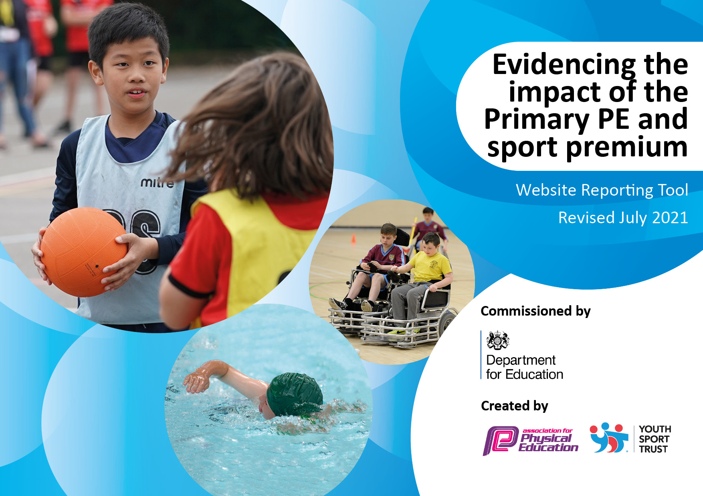
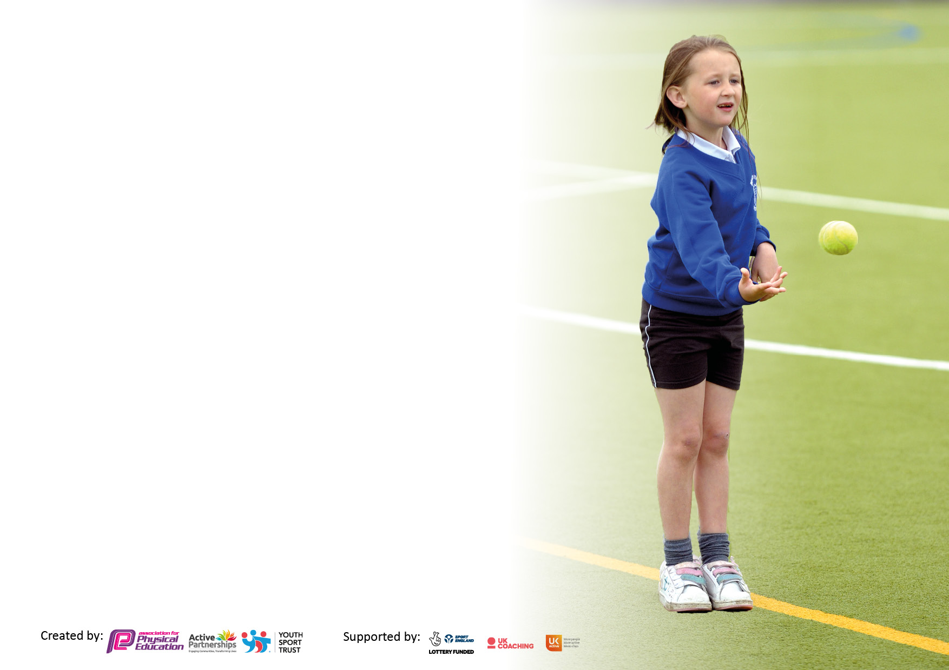

It is important that your grant is used effectively and based on school need. The Education Inspection Framework makes clear there will be a focus on ‘whether leaders and those responsible for governors all understand their respective roles and perform these in a way that enhances the effectiveness of the school’.

Under the Quality of Education Ofsted inspectors consider:
Intent - Curriculum design, coverage and appropriateness
Implementation - Curriculum delivery, Teaching (pedagogy) and Assessment
Impact - Attainment and progress

To assist schools with common transferable language this template has been developed to utilise the same three headings which should make your plans easily transferable between working documents.

Schools must use the funding to make additional and sustainable improvements to the quality of Physical Education, School Sport and Physical Activity (PESSPA) they offer. This means that you should use the Primary PE and sport premium to:

- Develop or add to the PESSPA activities that your school already offer
- Build capacity and capability within the school to ensure that improvements made now will benefit pupils joining the school in future years
- The Primary PE and sport premium should not be used to fund capital spend projects; the school’s budget should fund these.

Pleasevisitgov.ukfortherevisedDfEguidanceincludingthe5keyindicatorsacrosswhichschoolsshoulddemonstrate animprovement.Thisdocumentwillhelpyoutoreviewyourprovisionandtoreportyourspend.DfEencouragesschools to use this template as an effective way of meeting the reporting requirements of the Primary PE and sport premium.

We recommend you start by reflecting on the impact of current provision and reviewing the previous spend.

Schools are required to publish details of how they spend this funding, including any under-spend from 2019/2020, as well as on the impact it has on pupils’ PE and sport participation and attainment. All funding must be spent by 31st July 2022.

We recommend regularly updating the table and publishing it on your website throughout the year. This evidences your ongoing self-evaluation of how you are using the funding to secure maximum, sustainable impact. Final copy must be posted on your website by the end of the academic year and no later than the 31st July 2021. To see an example of how to complete the table please click HERE.

Details with regard to funding

Total amount carried over from 2019/20 | £8,273
Total amount allocated for 2020/21 | £21,050
How much (if any) do you intend to carry over from this total fund into 2021/22? | £0
Total amount allocated for 2021/22 | £20,050
Total amount of funding for 2021/22. To be spent and reported on by 31st July 2022. | £20,050
Swimming Data

Meeting national curriculum requirements for swimming and water safety.  N.B. Complete this section to your best ability. For example you might have practised safe self-rescue techniques on dry land which you can then transfer to the pool when school swimming restarts.  Due to exceptional circumstances priority should be given to ensuring that pupils can perform safe self rescue even if they do not fully meet the first two requirements of the NC programme of study | Due to COVID 19 awaiting results
What percentage of your current Year 6 cohort swim competently, confidently and proficiently over a distance of at least 25 metres?  N.B. Even though your pupils may swim in another year please report on their attainment on leaving primary school at the end of the summer term 2020.  Please see note above | %
What percentage of your current Year 6 cohort use a range of strokes effectively [for example, front crawl, backstroke and breaststroke]?  Please see note above | %
What percentage of your current Year 6 cohort perform safe self-rescue in different water-based situations? | %
Schools can choose to use the Primary PE and sport premium to provide additional provision for swimming but this must be for activity over and above the national curriculum requirements. Have you used it in this way? | No

Action Plan and Budget Tracking

Academic Year: 2020/21 | Total fund allocated: £29,323 | Date Updated: 31ST July 2021
Key indicator 1: The engagement of all pupils in regular physical activity – Chief Medical Officers guidelines recommend that primary school pupils undertake at least 30 minutes of physical activity a day in school |  |  |  | Percentage of total allocation:
 |  |  |  | %78
Intent | Implementation |  | Impact
Your school focus should be clear what you want the pupils to know and be able to do and about  what they need to learn and to  consolidate through practice: | Make sure your actions to achieve are linked to your intentions: | Funding allocated: | Evidence of impact: what do pupils now know and what can they now do? What has changed?: | Sustainability and suggested next steps:
- Ensure our high quality PE and school sport offer develops competent and confident movers with the aim of inspiring lifelong participation in physical activity.  - Use active lessons to increase physical activity levels and learning  - Educate children in the value and benefits of a healthy active lifestyle.  - Ensure facilities are in place to promote greater physical activity throughout the school day in EYFS  - Provide opportunities for daily physical activity.  - To increase pupils’ activity levels throughout the day. | - Develop a unique and personalised scheme of work tailored to our school intent and pupil needs  - Ensure facilities are in place to support physically active break and lunchtimes in the EYFS  - Through PE lessons and sport, ensure our children understand the role of movement in the development of their own physical fitness and wellbeing.  - Develop the PE curriculum to ensure lessons link to the multi-skills approach found in our PE policy.  - Develop action plan  - Purchase Resources | £22,972 | - Positive attitudes to health and well-being  - Pupils activity at lunch and break increased in EYFS  - New scheme of work in pace and being used on a consistent basis | Sustainability  - Children will continue to develop fine and gross motor skills and physical development will be accelerated.  - Children will continue in the present and the future to develop their social communication and turn taking skills.  - SEND children have more accessible resources to ensure rapid progression in line with their peers.  - Children have healthier lifestyles due to an increased participation in physical activity.  Next steps  - Monitor physical activity levels to ensure ALL classes meet the government guidelines of at least 30 minutes a day for each child in school time.  - Monitor quality of Education and the use of the new scheme of work
Key indicator 2: The profile of PESSPA being raised across the school as a tool for whole school improvement |  |  |  | Percentage of total allocation:
 |  |  |  | %4
Intent | Implementation |  | Impact
Your school focus should be clear what you want the pupils to know and be able to do and about  what they need to learn and to  consolidate through practice: | Make sure your actions to achieve are linked to your intentions: | Funding allocated: | Evidence of impact: what do pupils now know and what can they now do? What has changed?: | Sustainability and suggested next steps:
- High quality PE lessons delivered during curriculum time  - Use PE teaching to aid fine and gross motor skill development  - Use PE and sport to enable the development of life skills that are transferred to other curriculum areas, wider school and beyond.  - School curriculum provides opportunities for children to develop their physical, social, emotional needs.  - School curriculum provides opportunities for children to develop a healthy life style and what is needed to remain well. | - Develop and use whole school scheme of work as robust plans for teaching of the PE curriculum  - PE co-ordinator to deliver a series of staff meetings to help staff develops the four areas of the whole child – Physical, Social, Emotional and Health. | £ 1000 | - Personal development (physical skills, thinking skills, social skills and personal skills).  - Attainment and achievement, behaviour and attendance.  - PE physical activity and school sport have a high profile and are celebrated across the life of the school  - Children learn to respect and work with each other, exercise self-discipline and act in a safe and sensible manner.  - Continued progression of all pupils during curriculum PE lessons. | Sustainability  - Children continue to make great progress in all aspects of PE – Physical, social, emotional and health.  - Progression continues to be evident from reception through to year 6 with children developing a passion for sport.  - Staff continue to feel confident in their teaching of PE and are able to support new staff in their development.  - Staff uses the skills taught in PE to develop lunchtime and after school clubs.  Next Steps  - Identify the positive impact that PE and school sport has on academic achievement, behaviour and safety, attendance, health and wellbeing and SMSC through pupil voice  - Review School development plan, Whole school policies/PE policy School staff better equipped/more confident to teach PE in school - Monitoring use of schemes and whole school PE coverage  - Ensure PE and school sport is visible in the school (assemblies, notice boards, school website, local press, pupil reward and recognition of pupils)

Key indicator 3: Increased confidence, knowledge and skills of all staff in teaching PE and sport |  |  |  | Percentage of total allocation:
 |  |  |  | %12
Intent | Implementation |  | Impact
Your school focus should be clear | Make sure your actions to | Funding | Evidence of impact: what do | Sustainability and suggested
what you want the pupils to know | achieve are linked to your | allocated: | pupils now know and what | next steps:
and be able to do and about | intentions: |  | can they now do? What has
what they need to learn and to |  |  | changed?:
consolidate through practice:
- School staff better equipped more confident in the teaching of PE  - Raise the quality of learning and teaching in PE and school sport to deliver a broad, balanced and inclusive high quality PE and school sport provision (within and beyond the curriculum) to raise attainment.  - 1:1 lesson observations to monitor staff effectiveness and confidence.  - New curriculum to ensure that Gym, Dance and Games is progressive and the National Curriculum objectives are met in both key stages. | - Observe and monitor lessons to ensure high quality teaching and learning.  - Children to complete pupil voice questionnaires and results fed back to staff.  - VG to have write long term plan and progression map.  - VG to complete new curriculum for Dance, Gym and Games.  - VG to create individual 6 week plans for staff to follow.  - Dance lessons resources to be created and easily accessible for staff. | £3500 | - increased staff knowledge and understanding.  - All teachers confident at teaching the curriculum.  - High quality PE being taught throughout the school.  - Children’s progression evident in lessons observations.  - Students pupil voices response show high level of knowledge in the social, emotional and health aspects of the PE lessons.  - A more inclusive curriculum which inspires and engages all pupils. | Sustainability -  - Children continue to make good progress in all year groups.  - Children grow up to be well rounded individuals who have good social and emotional skills.  - Children have a healthy attitude to life and know how to keep their body healthy.  - Children understand and enjoy physical movement and extends to both in school and at home.  - Staff are confident at teaching PE and continue to develop children in the 4 key areas.  - Staff and children continue to develop a passion for not only PE but sport as well.  Next steps –  - Review staff confidence and competence in delivering high quality PE and school sport and allocate staff to upcoming CPD opportunities.  - Further one to one lesson observations to monitor staff effectiveness and confidence.

Key indicator 5: Increased participation in competitive sport |  |  |  | Percentage of total allocation:
 |  |  |  | %6
Intent | Implementation |  | Impact
Your school focus should be clear | Make sure your actions to | Funding | Evidence of impact: what do | Sustainability and suggested
what you want the pupils to know | achieve are linked to your | allocated: | pupils now know and what | next steps:
and be able to do and about | intentions: |  | can they now do? What has
what they need to learn and to |  |  | changed?:
consolidate through practice:
- Increased participation in competitive sport.  - Providing opportunities for children with SEND, the least active and the least confident to take part in competitive activities.  - Children to compete against peers in a variety of sports. | - Year groups to compete in intra class competitions.  - All children to take part in school sports day.  - Sports day to include events for SEND children to take part and shine in. | £1851 | - Vast majority of KS2 pupils participated in the intra-house competitions.  - Sports Day set up, participated in and ejoyed by ALL pupils.  - Silver school games marked achieved. | Sustainability  - Children have a developed resilience to losing and understand it is part of life.  - Children continue to develop teamwork skills.  - Children understand how to win and demonstrate appropriate behaviour.  Next Steps  - Continue to develop further competitive sport opportunities for other children.  - Provide children with the opportunity to compete against other schools.  - Children to be included in leadership and organising competitive sport within school.

