PE Funding

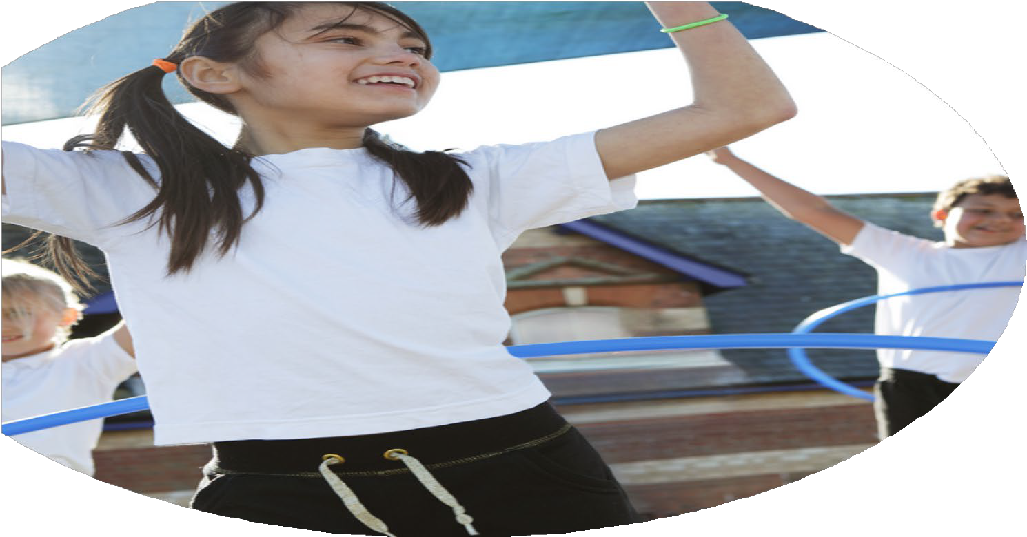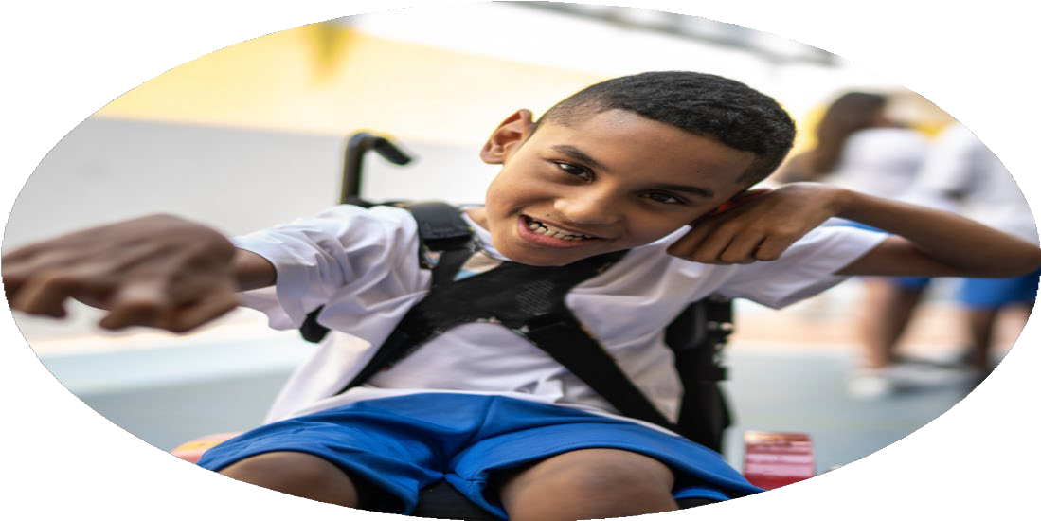

Evaluation Form

**Commissioned by**

**Created by**

Images courtesy of Youth Sport Trust

**PE Funding Evaluation Form**

 It is intended that this template should be used as preparation for the completion of the statutory digital reporting tool being introduced this academic year. You can upload data (including swimming) from this template onto this platform once it becomes accessible.

 Before you decide how you are going to use the funding for this academic year you should reflect and evaluate the impact of your use of the funding in 2023/24.

 All spending of the funding must conform with the terms outlined in the Conditions of Grant document.  The template is a working document that you can amend/update during the year.

 Based on your evaluation of last year’s funding you should decide what you intend to do this academic year, how you will do it, and what impact you expect it to have.

It is important that the funding is used effectively and based on your school’s needs.

 You must use the funding to make additional and sustainable improvements to the PE and sport in your school.  You must develop and add to the PESSPA activities that your school already offers.

*Summative digital reporting from June 2025 will continue to include swimming and water safety information therefore funding can be used to provide top-up lessons where necessary to ensure pupils meet national curriculum swimming requirements.*

**We recommend that you start by reflecting on the impact of current provision and reviewing your previous spend**

|  |  |  |  |
| --- | --- | --- | --- |
| What went well? | How do you know? | What didn’t go well? | How do you know? |
| Ensuring children have a good understanding and enjoyment of a variety of sport.  Introduction of new sports clubs to encourage pupil premium children to take part in extracurricular clubs at lunch and after school.  Targeted children working within school to improve their behavior. | 100% participation in Sport’s Day  Results from the end of unit intra tournaments between classes.  More variety of clubs and registers were monitored for attendance.  Less incidents in school. Teachers report a big improvement with targeted children. | Some of the year children were hesitant to perform in competitive sports in front of other people. Understanding that some children win and others loose.  Still more children would like more sports clubs and more opportunities at lunch for children who are unable to stay after school.  Still more support needed for other children who haven’t received it yet. | Pupil voice  Pupil voice  Conversations with staff and feedback from the pastoral team. |

|  |  |
| --- | --- |
| What are your plans for 2024/25? | How are you going to action and achieve these plans? |
| Intent | Implementation |
| To increase knowledge and skills of support staff working with SEND children and children who struggle in the school environment.  Children to experience a wide range of sports at playtimes, lunch and afterschool- especially children who are pupil premium.  Increased participation for all children in competitive sport.  To increase knowledge of teaching staff so all children can engage in effective regular physical activity.  Ensure the profile of PE and sport is raised across the curriculum by ensuring children have the opportunity to attend a variety of sporting participation events and receive the opportunity for children to attend sporting events to be inspired by athletes.  To increase participation in PE and Sport for girls.  Increased knowledge and understanding for staff when assessing PE in school and using that to improve children’s knowledge and attainment. | Coaches to work alongside support staff in order to give them the knowledge and skills to deliver sporting boosters independently. After school club to be provided specifically for these children. PE booster classes to be given specific identified children. Individual children who need more PE support identified and given one to one sessions.  Teaching staff to attend specific sport based courses to upskill them. Clubs monitored each term and registers crossed checked with pupil premium. Clubs then reviewed to reflect on potential new sports/clubs. School council to speak to their class and choose sports clubs children would like to attend. Summer term any pupil premium child who has not attended a club to be identified and provision provided  Links to be made with local football clubs. Opportunities for children to attend both inspire and excel through MPETT. Sports day to be accessed for all children from reception to year 6. Intra- sport end of term events to be organized for all year groups.  New staff to receive training by MPETT to ensure the school scheme of work is being taught effectively. Both PE coordinators and Sports Coach to receive training that can be fed back into school. VG to be released to work with other school and then feedback improvement that can be made. VG to work with new staff. BK to observe KS1 staff and support with any additional PE skills and knowledge they need.  Football stadiums, Wimbledon, SEND sports day etc. to be attended by targeted children. Sporting events children participate in to be celebrated in assemblies and on school weekly news letters. Rewards in the form of stickers, medals and Dojo’s to be given to children for both effort and achievement.  Girls football opportunities to available. Girls to have a football pitch specifically for them and supported by an adult. Girls football clubs to be run at lunchtime and after school for years 4,5 and 6. Girls to attend both intra and inter football competitions.  Staff to be trained in the new PE assessment. PE assessment to be implemented on a termly basis and PE coordinators to analyse the data for strength and weaknesses and use this information to support both staff and pupils. |

|  |  |
| --- | --- |
| What impact/intended impact/sustainability are you  expecting? | How will you know? What **evidence** do you have or  expect to have? |
| SEND children will feel PE is more accessible allowing them to develop skills better in turn increasing enjoyment of sport. They will be able to access the school curriculum or a tailored curriculum depending on their level of need.  Girls will have more access to football opportunities in school and develop a lifelong passion for it.  SEND children will have taken part in sports club and those that require it will have received one:one tuition which will upskill them physically in PE but also socially and emotionally.  All children will have an enjoyment of competitive sport and this will lead into them accessing competitive sport out of school and when at high school.  All teaching staff will confidently and competently teacher the school scheme of work effectively.  Children will be inspired to take part in PE and sport by attending sporting events and participating in events with school. Leading to increased participation in local clubs potentially leading to life long participation.  All children will make good progress in PE during core lessons. | Assessment data will be analysed and used to reflect. Conversations with SEN teachers, SENCO and parents.  Club lists, monitoring of playtimes and lunchtimes by VG and BK, attendance certificates for competition, pupil voice.  Registers kept by WB, assessment data completed by WB. Feedback from teacher regarding targeted pupils. Pupil voice.  Sport’s day races sheets, tournament results, registers and documents from MPETT competitions.  Observations sheets from BK observing KS1. Observation sheets from any new staff. Notes and agenda from meetings with partner school. Assessment data showing children’s progress over the year.  Pupil voice, photographs from events attended, children’s engagement in sport outside of school – discussion had with pupils by BK and WB.  Data analysis of end of year assessments, lesson feedback documents, notes from staff meetings and discussions with staff. |

|  |  |
| --- | --- |
| What **impact/sustainability** have you seen? | What **evidence** do you have? |
| SEND children who have had either individual sessions or small group sessions are now able to access PE within the class environment and have made great improvements physically, emotionally and socially. It has become part of their routine that they are more active and look forward to specific sessions.  Girls have a more easily accessed a platform for taking part in both school football and football within their community. Girls who were only in the school football teams now attend community clubs and some have even had trials for Manchester City girls club.  SEND children now access more lunch and after school sports clubs and enjoy taking part in a variety of sports. They are more confident in PE and more enthusiastic to take part in future clubs. Increased fitness level from benefiting from multiple sessions.  Children at Crossacres love to take part in sport and have developed a passion for not only participating but wanting to win and succeed when taking part in competitive sport. Parents are actively encouraged to come and support children in competitive sports and this has built a good relationship between school and parents.  All staff across school teach the progressive curriculum and all children engage in PE lessons. | Feedback forms from class teacher. Pupil voice forms. Club registers which show children are now able to access sports club. Assessment data. Increased numbers within the club.  Feedback from local clubs. Pupil voice. Club registers and documents from competitions attended. Girls can visibly be seen playing football at playtimes and lunch. Newsletters documenting their triumphs.  Club lists, pupil premium lists, pupil feedback forms, percentages children participating including waiting lists for some clubs that were previously not full. Increased sustained activity during curriculum PE lessons.  Sports day registers and race lists, Newsletters evidencing competitive sports, pupil voice and feedback from staff. Show and tell of achievements to class’ such as medals , trophies and certificates.  Assessment data, pupil voice, staff feedback forms, lesson observation sheets. |