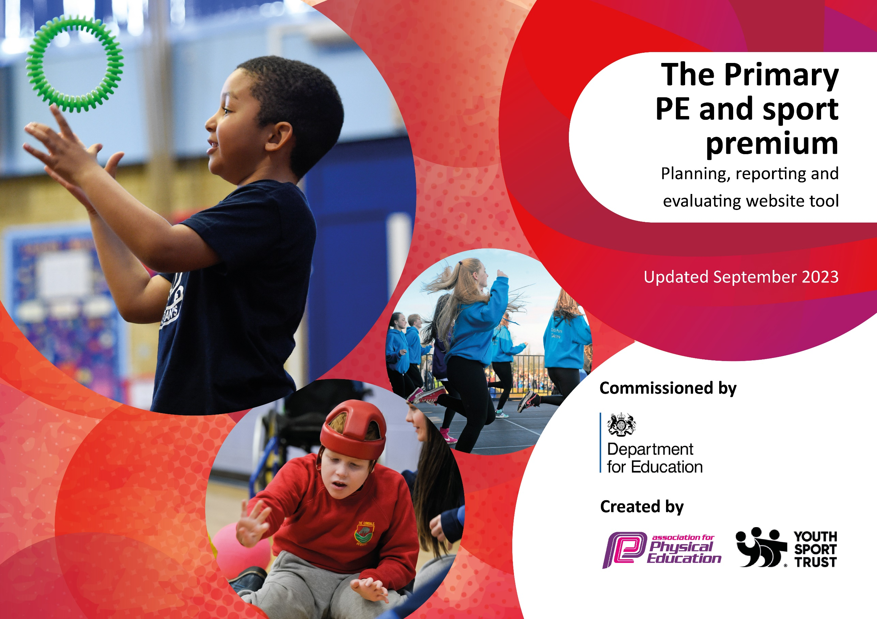

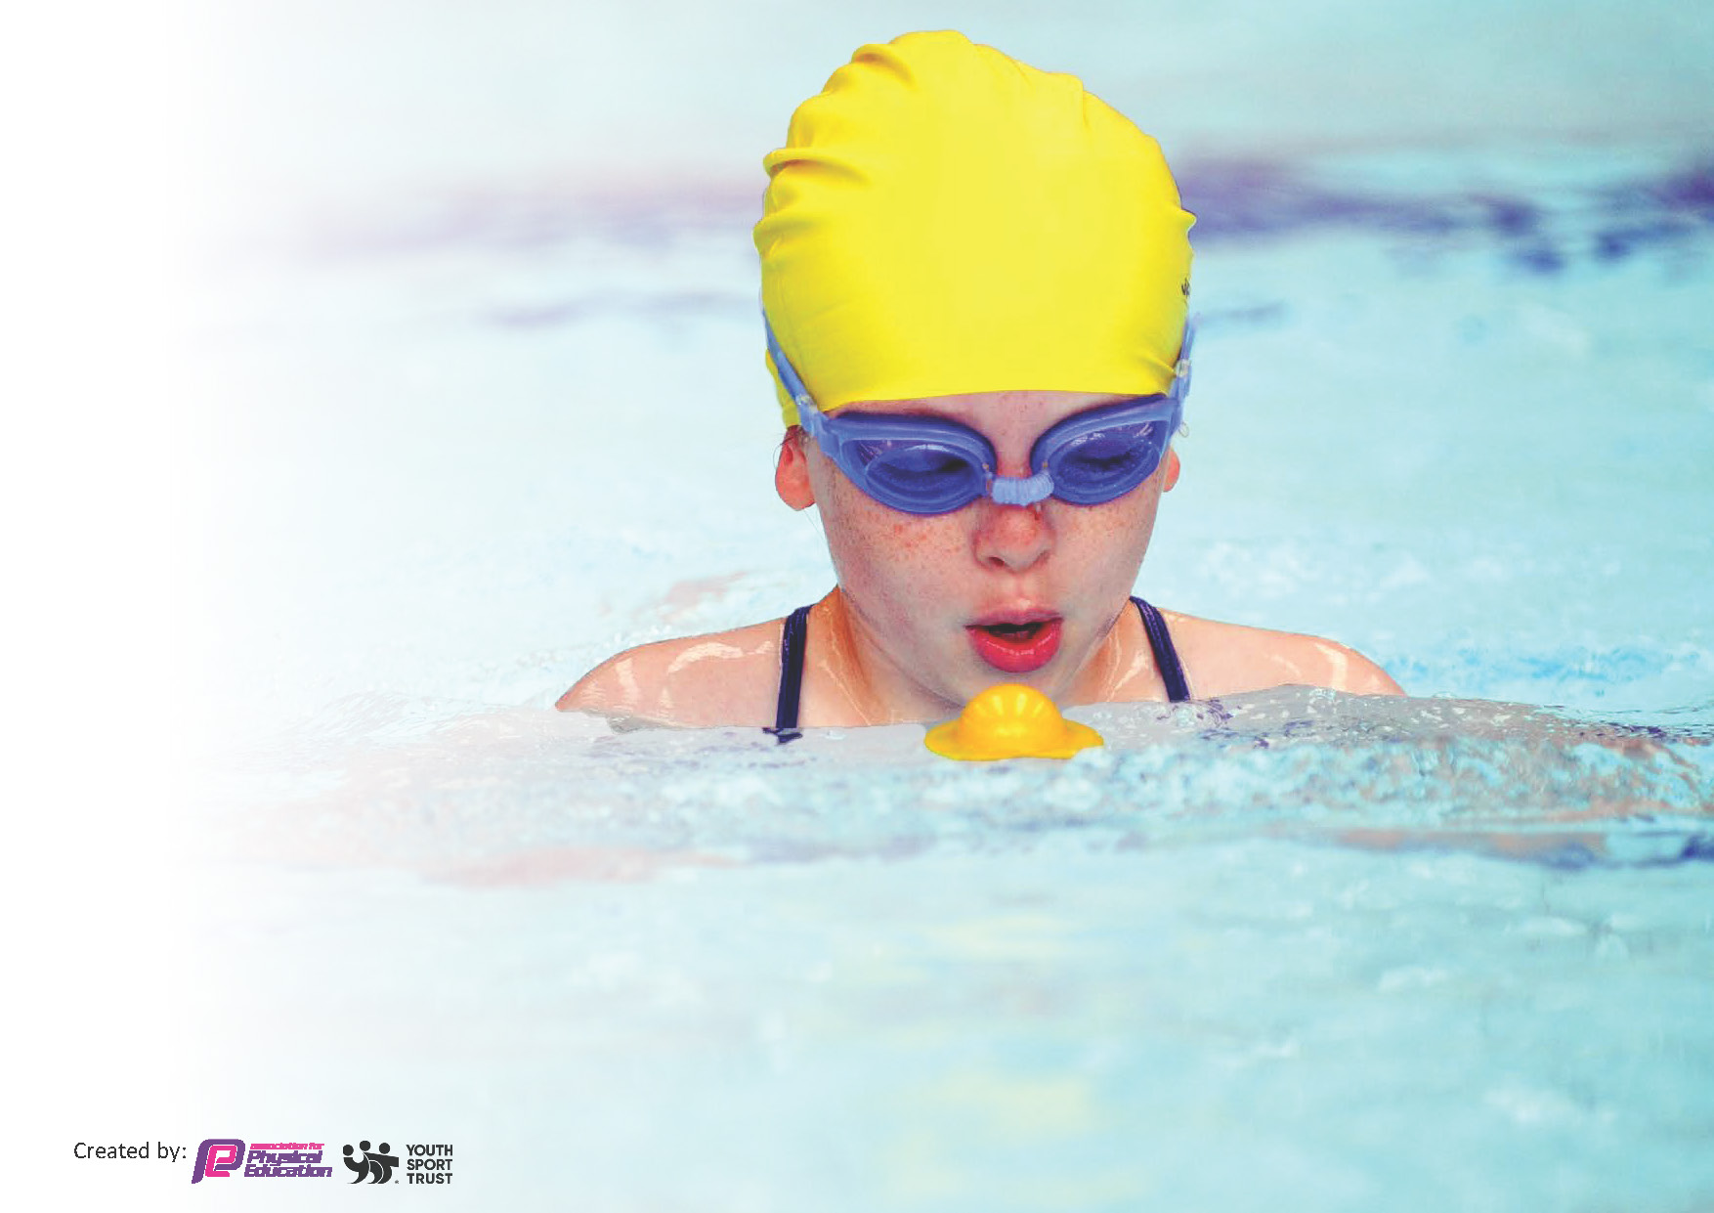
This template can be used for multiple purposes:
by:
- It enables schools to effectively plan their use of the Primary PE and sport premium
- It helps schools to meet the requirements (as set out in guidance) to publish information on their Primary PE and sport premium
- It will be an effective document to support Ofsted inspections enabling schools to evidence progress in Physical Education (PE) and evidence swimming attainment, which forms part of the PE National Curriculum. We would recommend schools consider
the Intent, Implementation and Impact of any spend, as examined within the Education Inspection Framework.

It is important that your grant is used effectively and based on school need.

Schools must use the funding to make additional and sustainable
improvements to the quality of the PE, School Sport and Physical Activity (PESSPA)
they offer. This means that you should use the Primary PE and sport premium to:

- Build capacity and capability within the school to ensure that improvements made now will benefit pupils joining the school in future years
- Develop or add to the PESSPA activities that your school already offers.

The Primary PE and sport premium should not be used to fund capital spend projects; the school’s core budget should fund these. Further detail on capital expenditure can be found in the updated Primary PE and sport premium guidance.

The Primary PE and sport premium guidance, outlines 5 key priorities that funding should be used towards. It is not

necessary that spending has to meet all the key priorities, you should select the priorities that you aim to use any funding towards.

Although completing this template is not a requirement for schools, schools are required to publish details of how they spend this funding. Schools must also outline what the impact this funding has had on pupils’ PE and sport participation and attainment and how any spending will be sustainable in the future. All funding must be spent by 31st July 2024.

The Department for Education has worked closely with the Association for Physical Education (afPE) and the Youth Sport Trust (YST) to develop this template and encourages schools to use it. This template is an effective way of meeting the reporting requirements of the Primary PE and sport premium.
Review of last year’s spend and key achievements (2022/2023)

We recommend you start by reflecting on the impact of current provision and reviewing your previous spend.

Activity/Action | Impact | Comments
Encourage enjoyment of PE and Sport with the aim of inspiring lifelong participation in physical activity.  Build a lifelong knowledge of the importance of physical activity through PSHE curriculum and assembly.  Continue to promote physical education through both PE and sport.  To understand the value of being in a team and making social connections from competing in sport. | - Increased participation in physical activity by ALL children.  - Increased levels of engagement by children.  - Increased participation in after school clubs.  - More active lunchtimes.  - Children have an improved understanding of health and wellbeing.  - Continue to follow the scheme of work.  - Pupils have a more positive approach to PE, sport and being active.  -Pupils learn communication skills and understanding others.

Key priorities and Planning
This planning template will allow schools to accurately plan their spending.

Action – what are you planning to do | Who does this action impact? | Key indicator to meet | Impacts and how sustainability will be achieved? | Cost linked to the action
Introduce new sports clubs at lunchtimes and after school- encourage pupil premium children to take part in extracurricular activities. | Pupils who will take part.  Teaching staff, TA’s and School sports coach who will run the club. | Key indicator 2 -The engagement of all pupils in regular physical activity – the Chief Medical Officer guidelines recommend that all children and young people aged 5 to 18 engage in at least 60 minutes of physical activity per day, of which 30 minutes should be in school.  Key indicator 4: Broader experience of a range of sports and activities offered to all pupils. | More pupils meeting their daily physical activity goal, more pupils encouraged to take part in PE and sporting activities.  Children also develop a wider enjoyment of a variety of sports.  More chances to try a wider range of sports outside the curriculum.  Children are provided with pathways to outside clubs that they can join. | £5000 costs for additional coaches to support lunchtime sessions.  £1000 costs for new equipment in order to run the clubs.

Children who struggle within the school environment to receive sporting opportunities to help them regulate themselves within school. | Targeted group of children with high-level need.  Other vulnerable children who will benefit from a smaller group environment.  Teacher, Sports Coach, lunchtime organizer and 1:1’s | Key Indicator 2: The increased engagement of all pupils in regular physical activity.  Key Indicator 3: The raising of the profile of PE and sport across the school, to support whole school improvement.  Key indicator 4: Broader experience of a range of sports and activities offered to all pupils.  Key indicator 5: Increased participation in competitive sport. | Children are able to sustain longer concentration in class.  Children have the opportunity to release pent up energy in a positive and safe environment.  Children learn life skills ie: emotional regulation, patience, turn taking and the ability to win and lose.  Children are able to function within the school environment. | £6000 equipment and resources and a resources top up mid year.  £3000 on staff training
To ensure children have a good understanding and enjoyment of a variety of competitive sport. | Whole school approach so all children can access a range of competitive sports.  All staff. | Key Indicator 2: The increased engagement of all pupils in regular physical activity.  Key Indicator 3: The raising of the profile of PE and sport across the school, to support whole school improvement.  Key indicator 4: Broader experience of a range of sports and activities offered to all pupils.  Key indicator 5: Increased participation in competitive sport | Children have regular opportunities to engage in a variety of competitive sports.  Children have developed a passion for a wide range of sports. Especially sports children would not normally have accessibility to. | £3000 for appropriate equipment
For all children to take part in a Sports Day to encourage their love of competitive sport. | Whole school approach so children can access at least two races.  All staff | Key Indicator 3: The raising of the profile of PE and sport across the school, to support whole school improvement.  Key indicator 4: Broader experience of a range of sports and activities offered to all pupils.  Key indicator 5: Increased participation in competitive sport | Children to develop resilience and be able to lose and accept defeat with grace.  Children to show good sportsmanship when winning and learn how to commiserate others. | £2000 for rewards  £1000 for grounds preparation

Key achievements 2023-2024
This template will be completed at the end of the academic year and will showcase the key achievements schools have made with their Primary PE and sport premium spending.

Activity/Action | Impact | Comments
Introduce new sports clubs at lunchtime and after school - encourage pupil premium children to take part in extra-curricular activities.  Children who struggle within the school environment to receive sporting opportunities to help them regulate themselves within school.  To ensure children learn basic skills and tactics within a wide range of sports and enjoy competitively. | More pupils meeting their daily physical activity goal, more pupils encouraged to take part in PE and Sport Activities.  Children develop keys skills at an early age to help with sport in participation throughout life.  Children also develop a wider enjoyment of a variety of Sports.  Children are able to sustain longer concentration in class. Children have the opportunity to release pent up energy in a positive and safe environment. Children learn life skills i.e: emotional regulation, patience, turn-taking and the ability to win and lose. | All pupil premium children were offered a sports club during the year.  All sports clubs were provided for free by school.  All clubs were filled to capacity.  Individual and small groups given targeted and specialist support to help them develop in school. SEN benefitted from small group work that helped both their social and emotional needs.  Slow paced lessons, differentiation and similar working level allows for more in depth skill development.

Swimming Data
Meeting National Curriculum requirements for swimming and water safety.
Priority should always be given to ensuring that pupils can perform safe self-rescue even if they do not fully meet the first two requirements of the National Curriculum programme of study

Question | Stats: | Further context  Relative to local challenges
What percentage of your current Year 6 cohort can swim competently, confidently and proficiently over a distance of at least 25 metres? | 100% - 25 metres  10% - 50+ metres
What percentage of your current Year 6 cohort can use a range of strokes effectively [for example, front crawl, backstroke, and breaststroke]? | 61%

What percentage of your current Year 6 cohort are able to perform safe self-rescue in different water-based situations? | 85%
If your schools swimming data is below national expectation, you can choose to use the Primary PE and sport premium to provide additional top-up sessions for those pupils that did not meet National Curriculum  requirements after the completion of core lessons. Have you done this? | No
Have you provided CPD to improve the knowledge and confidence of staff to be able to teach swimming and water safety? | No

Signed off by:

Head Teacher: | Suzanne Blay
Subject Leader or the individual responsible for the Primary PE and sport premium: | Victoria Grzelak
Governor:
Date: | 4th October 2024

