Child Friendly Anti-Bullying Policy
This policy has been written by the school council and the anti-bullying ambassadors.
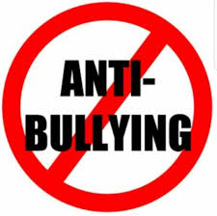
This school is a place where everyone has the right to be themselves. It is a place where everyone can feel safe, be happy and learn. Everyone at our school is equal and acts with respect and kindness towards others. Our school is a place where bullying is not allowed.

What is bullying?
Bullying is when a person is hurtful or unkind to someone else, on purpose and more than once. Bullying can be done by one person or by a group of people. A useful way to remember bullying is
SEVERAL TIMES ON PURPOSE
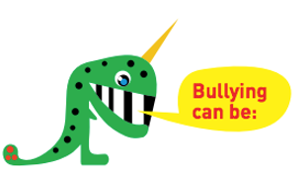
- Hitting or saying you are going to hit someone
- Touching someone when they don’t want you to
- Calling someone names, teasing, using rude language or saying nasty things about someone to them, or to other people
- Stealing or damaging someone else’s belongings
- Ignoring someone on purpose or leaving them out
- Sending hurtful or unkind texts, emails or online messages to someone or about someone
- Blaming someone else for what someone else has done
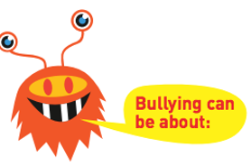
- Their race meaning where their family comes from
- Religion or beliefs
- Family or culture
- Sexist bullying - which is bullying someone because of their gender (meaning whether they are a boy or a girl)
- Homophobic or bi-phobic bullying
- Transgender bullying
- Special educational needs or disability
- What someone looks like
- Where someone lives
- Who they live with
- How someone acts/speaks (their accent)

Why does bullying happen?

Although bullying doesn’t happen very much at this school it might happen. Bullies can be older or younger. Bullies pick on people who may be different in some way and try to make them feel worse.

If you are being bullied remember that it is never your fault.

Where does bullying happen?
Bullying can happen anywhere and everywhere!

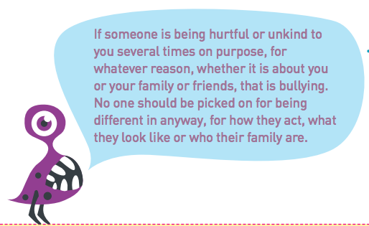

What should I do if I’m being bullied?
If you are being bullied it is important to tell someone that you trust. Tell an adult or friends, either at school or at home. If you have already told an adult about bullying you can still tell them again. You can:
- Tell a teacher – your class teacher or any other teacher
- Tell an anti-bullying ambassador who will be able to help you
- Tell any other adult staff in school
- Tell an adult at home
- You can also write a note about the bullying in the worry boxes
- You can also call Child Line at any time for free on 0800 1111. They will not tell anyone else about what you have said.
- If you tell a teacher or an adult at school they will be able to help you. They may tell another teacher like your class teacher, or a parent or carer so that they can help you. Telling an adult will never make the bullying worse. They will talk to you and the bully to find ways to stop the bullying.

Written by
School Council and Anti-Bullying Ambassadors 2019
Reviewed by School Council November 2021

