Updated September 2023

Behaviour and Attitudes Policy September - 2023

Policy and Behaviour Management Guidelines

Intent
At Crossacres Primary Academy we aim to create a positive atmosphere where all members of the school community feel valued and respected.

Our school behaviour policy is designed to support the way in which all members of the school can live, work and learn together in a productive and harmonious way.

We believe that all the children at Crossacres Primary Academy have a right to an education which offers them the best opportunity to reach their full potential in life and that everyone within school is working to provide the environment in which this may happen.

Children are taught how to behave from the very start of their journey in Nursery.

Emphasis is placed on the Prime Areas in EYFS (PSED) and good behaviour is modelled and explained to children. The golden rules are shared with the children and expectations are shared with regards to how we treat each other.

Role play is key in EYFS to model the correct behaviour and demonstrate how we respect one another.

Children are taught that there are consequences if they make the wrong choice and reflect on why they made it.

This policy is based on advice from the Department for Education (DfE) on:
- Behaviour and discipline in schools
- Searching, screening and confiscation at school
- The Equality Act 2010
- Use of reasonable force in schools
- Supporting pupils with medical conditions at school
It is also based on the special educational needs and disability (SEND) code of practice.

This policy is linked with the following school policies:
SEN
Safeguarding
Equality
Bullying
Exclusions Toolkit V2

School Behaviour Management Aims

- To promote good behaviour, self- discipline and respect for themselves and others whilst demonstrating positive attitudes to their education.
- To enable children to learn without disruption.
- To enable children to play a role in creating a school environment in which commonalities are identified and celebrated, difference is valued and nurtured, and bullying, harassment, and violence are never tolerated.
- To enable teachers to teach without disruption
- To promote and celebrate outstanding learning attitudes.
- To have consistent strategies used throughout the school.
- To involve parents in the management of their children’s behaviour.
- To provide a framework in which children feel secure.
- To reward and reinforce good behaviour both within and outside the classroom. To expect this good behaviour to continue when pupils are not at school or under the lawful control of members of staff.
- To involve all staff in the process of managing behaviour.

A Positive Approach at Crossacres Primary Academy
An effective behaviour and behaviour management policy is one that has high expectations and supports the children in developing self-discipline and a positive self-image. Self-esteem affects all thinking and behaviour and we believe that this impacts on learning and performance. This starts with our youngest children in Nursery and is embedded on their journey through the school. We aim to provide positive experiences and reward good behaviour. By reinforcing good behaviour, we provide role models and emphasise our high expectations and encourage achievement. At Crossacres successful relationships between teaching staff and children is paramount; we believe that positive relationships lead to positive behaviour.

We all follow our golden rules:

Golden Rules for KS1 & KS2
The Golden Rules (linked with loss of Golden Time if broken)

- Do be gentle, don’t hurt anybody.
- Do be kind and helpful, don’t hurt people’s feelings.
- Do be honest, don’t cover up the truth.
- Do work hard, don’t give up.
- Do look after property, don’t waste or damage things.
- Do listen to people, don’t interrupt
Sanctions / Consequences
The school operates sanctions based on the loss of children’s Golden Time. At the start of the week everyone has half an hour, weekly on a Friday afternoon. If the golden rules are broken, these minutes are taken away from the child. The child cannot earn these minutes back. We use traffic lights as a visual symbol for children to understand the consequences of their behaviour.
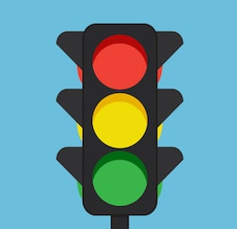
The Traffic Light System
Step 1:
When a child does not follow the golden rules they receive a warning to remind them of the consequences of unacceptable behaviour.
Step 2:
If the behaviour persists their name is placed on the green traffic light. The child will also be asked to move seats at this point.
Step 3:
If the behaviour persists the child’s name is placed on the amber traffic light. The child then misses 5 minutes of Golden time at the end of the week. During this time, they sit quietly in the class while the rest of the children enjoy Golden time.
Step 4:
If the behaviour persists or the child commits a serious offence, the child is moved to the red light and is sent to another Year Group. The child misses 15 minutes of their Golden Time. The incident is recorded on CPOMS.

We must ensure that in dealing with such behaviour we use appropriate sanctions which are age appropriate, immediate, fair and consistent. We make clear why the sanction is being applied and what change in behaviour is required to avoid future punishments. We avoid group sanctions as they can breed resentment. We are also mindful that it is the behaviour rather than the child that is being punished i.e. ‘Your behaviour is ……..’. We also believe that we must apply a sense of proportion to all situations and that the sanction is appropriate to the offence.

Criteria for placing children on traffic lights
Answering back
Aggressive behaviour
Refusing to answer
Rudeness
Disruption of work
Refusal of work
Refusal to carry out reasonable instructions
Lack of co-operation
Refusal to share school resources
Retaliation
Name calling (of any malicious nature)
Damaging work
Throwing things
Littering
Repeated interruption

Severe Clause-
If a child commits a severe clause offence the Head of Pastoral care will become involved with the child and their parents/carers. The Head of Pastoral care will work with the class teacher to decide the next steps and consult with SLT where appropriate.

Criteria for Severe Clause
Violence
Swearing at adults or children
Defiance/repeated cheek to adults
Bullying
Racism
Homophobia
Refusing to follow instructions pertaining to safety
Leaving school without permission

In these instances, we may use seclusion for children so the offending child is away from other children and not disrupting other children and their learning. During this time, children will be supervised by an adult member of staff.

Red light consequences
- If a child receives a second red light in half a term the class teacher will contact the parents via Class Dojo.
- If a child acquires their third red light their parent will be asked to attend a meeting with the class teacher.
- If a child gains a fourth red light the parents will be asked to attend another meeting with the class teacher and a behaviour diary will be introduced.
- If the child gains a fifth red card, the child will be given a Head teacher’s red behaviour diary. At this stage the child will be put on one-day seclusion in their red card class. They will also stay with that class for lunch and playtimes. He or she will also report to the Head of Pastoral care. This will provide an opportunity for the child to talk about his unwanted behaviour and how to improve matters.

NB- If this behaviour persists or there are extremes of aggressive, violent behaviour within the half term the child may be reduced to a part-time timetable or be excluded.

Golden Rules for EYFS
- Be happy
- Be kind
- Be polite
- Do listen
- Do sit properly
- Do your best!

NB- Children do not lose Golden Time in the Nursery as golden time does not happen. The sanction for being on the traffic lights needs to be instant.
These sanctions are;
Green traffic light – 2 minutes’ time out next to an adult.
Amber traffic light – 10 minutes’ time out next to a teacher.
Red traffic light- parent is notified and the child loses Class Dojo points. They also have 15 minutes’ time out with the Assistant Headteacher of EYFS. (Miss Kirkwood.)
Responsibilities
The main responsibility for managing children’s behaviour lies with the individual class teacher. Colleagues and school leaders will support teachers in addressing issues in behaviour management, no teacher will have the right to abdicate their overall responsibility for their children in their charge.

It is also the responsibility of all other paid staff, including teaching assistants, site managers, office workers and lunchtime organisers to support colleagues in carrying out our behaviour management guidelines.

Exclusions

If the behaviour policy has been followed and bespoke support has been put into place but a child continues to display severe and ongoing behaviour issues, then the school may resort to following the Exclusions Toolkit provided by the Local Authority.

Teaching

While some children can present extreme behavioural issues because of external factors, behaviour management is linked significantly to the quality of the teaching and learning provided. Where learning experiences are well structured and meet the needs of the individual child then disruptive behaviour will be reduced.
To achieve this, teachers should:

- Provide a variety of inclusive teaching styles and approaches for different lessons to include all learners and provide appropriate challenge.
- Match work to children’s needs and abilities.
- Ensure their classroom environment is conducive to effective organisation, learning and behaviour management.

Routines and Classroom Organisation
All teachers should have high expectations, routines and organisation within their classroom. These should be taught and explained to the children and periodically revisited. It is essential that all staff adhere to common daily routines. These routines should include:

- Beginning and end of the day- children enter school at 8.40am and the atmosphere is calm and quiet during the Reading for Pleasure time.
- Clear routines for changing for PE and games- the expectation is that children get changed for PE in silence.
- Clear routines for the distribution and handling of equipment
- Clear routines for the start and end of learning activities- during lesson time, there should be a quiet atmosphere where all children can concentrate and learn.
- Clear behaviour expectations for lining up to return into class after break and dinnertime.
- Children should be silent lining up to enter and exit the hall for assemblies.

N.B - Any child who needs to go to the toilet must be allowed to go without punishment. Children who misbehave whilst in the toilets will initially receive a warning and if problematic behaviour persists, they will lose their right to go to the toilet independently.

Playtimes and Lunchtime
At the end of playtime or lunchtime a whistle will be blown. The first whistle means stand still; the second means line up quietly. The children will be expected to quickly put the equipment they are playing with away on their way to the line. The children are then collected by the teachers and T.A.’s and walked into school by the agreed entrance.

All lunchtime supervisors are to adhere to this policy and look to reinforce positive behaviour. The incentive for the lunchtime organisers to reward good behaviour at lunchtimes are the Class Dojo’s (please see below) which they can award in class. These can be awarded for any positive behaviour, including;
- Being polite and using manners
- Helping a friend
- Being kind to others.
- Moving sensibly and respectfully around school.

Lunchtime Organisers are also supported with behaviour at lunch by our Pastoral Lead, Mr. Campbell and by all members of SMT. All behaviour incidents are recorded in behaviour diaries that the Lunchtime Organisers write in and give back to the class teacher. This ensures consistent communication between class teacher and lunchtime organiser.

Moving Around School

When staff move children around school they must ensure that the children walk in a line in a sensible, quiet and safe manner. Teachers must position themselves where they can see all parts of their class. Children should be told clearly the stopping points where they must wait. All children should be aware of the expectations of how they move around school. This involves being quiet, not running, holding doors for others and walking calmly.

Behaviour checklists

Classroom
- Know the names and roles of all the staff in your classroom.
- Meet and greet pupils when they come into the classroom.
- Display rules in the classroom- ensure pupils and staff know what they are.
- Display the tariff of sanctions in class.
- Have a system in place to follow through with all sanctions.
- Display the tariff of rewards in class.
- Have a system in place to follow through with all rewards.
- Have a visual timetable on the wall.
- Follow the school’s behaviour policy.
Pupils
- Know the names of your pupils.
- Follow the traffic lights system for the children in your class who misbehave.
- Ensure all adults in your room understand and follow these rules.
- Ensure you understand your pupil’s special needs.
Teaching
- Ensure all resources are prepared in advance.
- Praise the behaviour you want to see more of.
- Praise the children doing the right thing more than criticising those who are doing the wrong thing.
- Differentiate.
- Stay calm.
- Have clear routines for transitions and stopping the class.
- Teach the children in your class the routines they need to know.
Parents
- Give feedback to parents about their child’s behaviour – let them know about the good days as well as the bad ones.
- Adhere to our Behaviour policy.

Rewards
The school’s behaviour management will not be effective without the use of a wide range of rewards. These should be for both the individual and the class.
We use the online system of Class Dojo!
We use this as a behaviour incentive and it is a successful way to communicate with parents directly via the app.
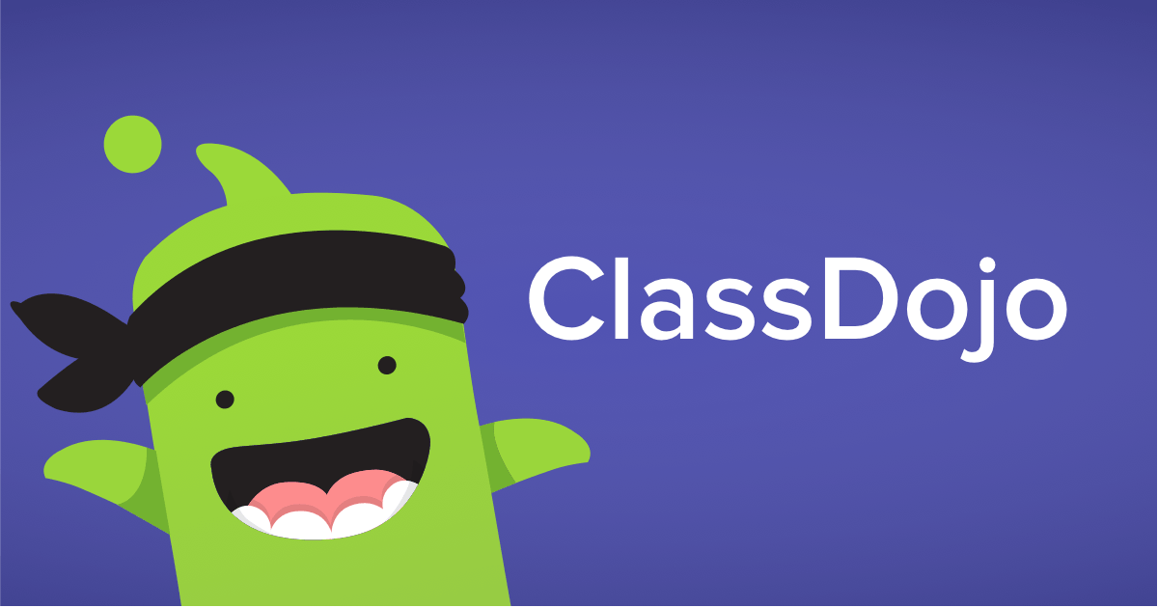

Every child has an avatar that is awarded points for good behaviour! Parents / carers can view this at home via the app. Teachers can encourage students for any skill or value — whether it's working hard, being kind, helping others or something else!
The skills and values available are; being hardworking, listening, being kind to others, teamwork, persistence, being on task, participating and working hard!
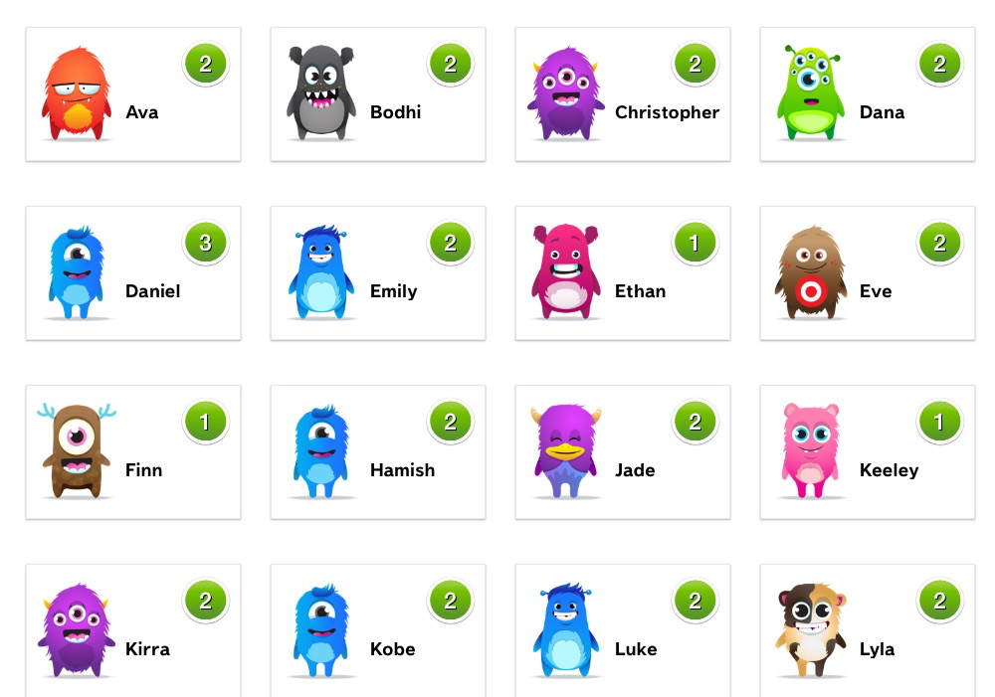

Class Dojo, enables us to share with parents/carers the behaviour of their child and the positive achievements within school. Parents/cares can view reports on their child’s behaviour and which skills or values they have received points for. Furthermore, whole class reports and overviews can be produced for teachers. ALL adults in school can award class dojo’s!

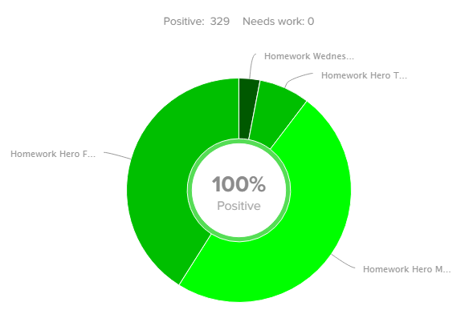

Golden Time:

Each week on a Friday afternoon Reception to Year Six will take part in Golden Time. This is a very special time to reward the children for following the school and class rules all week. During Golden Time the children can take part in special activities that they really enjoy doing, for example art work, construction kits or games.
At the beginning of the week the children sign up to the activity they would like to take part in so they can look forward to it. If the children keep the school’s Golden rules all week they will get their full 30 minutes of Golden time

Celebration Class Assemblies – Positive Attitudes

A class assembly will be held on Monday morning to celebrate the children’s achievements from Reception to Year 6. This is an opportunity to promote the outstanding learning and behavioural attitudes we expect in the school. In this assembly the following children and groups will be recognised:

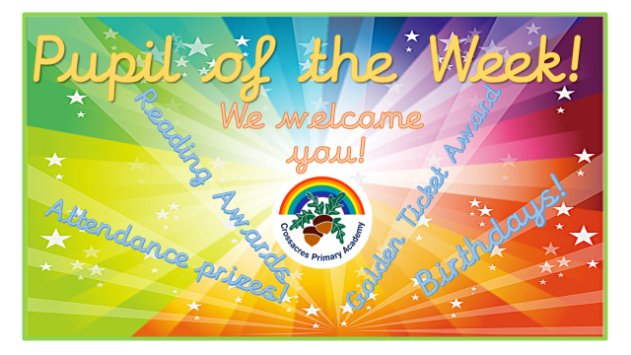

CPA- Award
Children are selected for the below awards that are linked to our school ethos of:
Challenge, Progress and Aspire!

1. Who has challenged themselves this week to overcome a difficulty? (resilience)
2. Who has made the most progress in a particular subject?
3. Who has aspired to be a good citizen through knowing and understanding the British Values?

KS1 children will look at and identify a picture representing one of the British Values.
KS2 children will select a British Value and talk to their classmates about it the following week.

- Any awards, trophies or certificates from outside of school are celebrated.
- Children who have a birthday that week are sang to

EYFS Star of the Week – Nursery
Children receive a certificate in their class assembly. There is one child from each group chosen weekly.

Break time and lunchtime behaviour
Poor behaviour at playtime and lunchtime is dealt with as a separate issue to classroom behaviour. If a child misbehaves during playtime or lunchtime, the first response is:
1. Time stood next to lunchtime organiser.
2. If the behaviour persists members of staff may use Time Out as a sanction.
The member of staff must inform a member of the SMT so arrangements can be made. A log is kept of the children who attend and the actions that brought them there. Parents of children who appear regularly at Time out will receive a message on Class dojo from their class teacher to discuss the issues involved. Activities during Time out may vary from reflecting on the child’s poor behaviour both verbally and in writing, making a positive contribution to the whole school or other appropriate actions including mindfulness colouring in for calm and peaceful reflection.

Traffic lights must not be used as a sanction during break time or lunchtime.

EYFS
The Foundation team will follow a similar traffic light system but will speak to parents/carers at the end of the day if a child is put on the traffic lights. Foundation staff will need to think carefully about what are appropriate consequences for very young children and will need to implement them sensitively.

Behaviour Management and the SEN register
At Crossacres we are aware that some children have additional needs which may make it difficult for them to follow the usual school behaviour policy without additional support. Staff should liaise with the SENCO regarding these children.

EYFS has an important role in the early identification of children who may subsequently present behavioural difficulties. Our aim must be the early identification and support for these children.

Children who repeatedly present behaviour problems will initially be recorded on CPOMS. This helps us to build up a picture of any patterns or triggers for individual children. If the combination of rewards and consequences described above, do not change the unacceptable behaviour then consideration will need to be given to putting the child on the special needs register and an individual behaviour programme (IBP) will need to be prepared for them. Teachers will be asked to log all incidents involving specified children.

Some children may have ongoing difficulties with following the behaviour policy for a variety of reasons. In this instance staff will liaise with the Pastoral team and SLT and a decision will be made whether we need to refer to other professionals such as Early Help, Educational Psychology, CAMHS, or behaviour support specialists. These referrals will be made in conjunction with the child’s parents and they will be kept informed throughout the process. This support is put into place to minimise the risk of permanent exclusions. Children who present with severe ongoing behaviour issues will have a bespoke behaviour system written up for them, depending on their specific needs.

Staff understand that poor behaviour may indicate underlying safeguarding concerns and SLT will support individuals by providing interventions to prevent exclusion in consultation with the SENCO/DSL/other relevant agencies.

Anti-Bullying
At Crossacres we are committed to providing a warm and caring environment for all our children so that they can learn and play in a relaxed and secure environment. The aim and implementation of our policy is to provide guidelines for identifying, and taking appropriate actions to deal with any incidents thereby creating an ethos where bullying is totally unacceptable.
We define bullying as being the repetitive, intentional harming of one person or group by another person or group, where the relationship involves an imbalance of power.
Bullying is, therefore:
- Deliberately hurtful
- Repeated, often over a period of time
- Difficult to defend against
Bullying can include:

Type of bullying | Definition
Emotional | Being unfriendly, excluding, tormenting
Physical | Hitting, kicking, pushing, taking another’s belongings, any use of violence
Racial | Racial taunts, graffiti, gestures
Sexual | Explicit sexual remarks, display of sexual material, sexual gestures, unwanted physical attention, comments about sexual reputation or performance, or inappropriate touching
Direct or indirect verbal | Name-calling, sarcasm, spreading rumours, teasing
Cyber-bullying | Bullying that takes place online, such as through social networking sites, messaging apps or gaming sites

Please read our Anti-bullying policy for further detail

Confiscation of inappropriate Items
At Crossacres Primary Academy we have the power to search and confiscate items from children. A member of SLT must be present, with another member of staff when a child is searched.
Taken from DFE; Behaviour & Discipline in Schools 2016
Power to search without consent for “prohibited items” 9 including:
• knives and weapons
• alcohol
• illegal drugs
• stolen items
• tobacco and cigarette papers
• fireworks
• pornographic images
• any article that has been or is likely to be used to commit an offence, cause personal injury or damage to property; and
• any item banned by the school rules which has been identified in the rules as an item which may be searched for.

Malicious allegations
Where a pupil makes an accusation against a member of staff and that accusation is shown to have been malicious, the headteacher will discipline the pupil in accordance with this policy. Please refer to our safeguarding policy for more information on responding to allegations of abuse. The headteacher will also consider the pastoral needs of staff accused of misconduct.

Physical restraint
In some circumstances, staff may use reasonable force to restrain a pupil to prevent them:
- Causing disorder
- Hurting themselves or others
- Damaging property
Incidents of physical restraint must:
- Always be used as a last resort!
- Be applied using the minimum amount of force and for the minimum amount of time possible
- Be used in a way that maintains the safety and dignity of all concerned
- Never be used as a form of punishment
- Be recorded and reported to parents.
At Crossacres we recognise that changes to a child’s behaviour or extreme behaviour, can be an indicator of abuse or neglect. The safeguarding team and SENCO will support the family and child with this.
For further details, please refer to our Physical Restraint Policy.
Training
Our staff are provided with training on managing behaviour as part of the induction process. Behaviour management will also form part of continuing professional development. If a member of the teaching staff need to get further support or want further training in behaviour management, how to access this is shared during induction or liaison with a member of SLT.

Pupils’ Conduct outside the School Gates- Teachers’ Powers
Subject to the behaviour policy, teachers may discipline pupils for:
misbehaviour when the pupil is:
(taken from Behaviour & Discipline in Schools DFE)
- taking part in any school-organised or school-related activity or
- travelling to or from school or
- wearing school uniform or
- in some other way identifiable as a pupil at the school.
- or misbehaviour at any time, whether or not the conditions above apply, that:
- could have repercussions for the orderly running of the school or
- poses a threat to another pupil or member of the public or …
- could adversely affect the reputation of the school.
In all cases of misbehaviour, the teacher can only discipline the pupil on school premises or elsewhere when the pupil is under the lawful control of the staff member.

Online Behaviour
We expect our pupils to demonstrate responsibility and kindness when communicating online. This is taught at the start of each academic year in the pupils’ E-Safety lessons. Through these lessons the children are taught:
- How to report things that have made them uncomfortable online.
- How to identify inappropriate behaviour online.
- The seriousness of online bullying.
- The harmful effects of online bullying.
- The dangers of contacting people that are not their friends.
- Which details to always keep private.
- How to set safety controls on various applications.
We are aware that negative online behaviour can seriously affect a child’s mental wellbeing and thus damage their emotional and academic progression. We teach our children to report incidents of online abuse to the school where we can deal with it. Depending on the severity of the abuse, the SLT will make a decision about the outcomes for the perpetrator. At every step, the school will liaise with all parents/carers of children involved.
School Prefects
We feel it is essential that each member of the school community takes responsibility for ensuring outstanding behaviour and attitudes are maintained throughout.

At the start of each academic year, children in Year 6 who have personified the behaviour and attitudes that we expect throughout their school career will be chosen to be prefects. Their duties will include:
- Helping to look after younger children.
- Being visible role models that the rest of the school can look up to.
- Exemplifying perfect behaviour in class, in the corridors and in the playground.
- Promoting and rewarding good behaviour in assemblies.
- Keeping communal areas tidy.
- Identifying positive behaviours and highlighting them to class teachers.
- Providing moral and emotional support to younger members of the school.

