CROSSACRES NEWSLETTER

12th March 2021

RED NOSE DAY – FRIDAY 19th MARCH
Our red nose theme this year is to wear ‘something to make you smile’. This could be your favourite outfit, a fancy dress costume or just your brightest colour top which makes you happy! Donations are 50p to your class teacher.

SCHOOL LUNCHES
We are able to offer a hot lunch option in addition to a choice of Ham or Cheese Sandwich. Please see below for the menu options. Please contact the school office if you wish to change your child’s lunch option, as a week’s notice is required as we have to order the food in advance. School lunches cost £11.50 a week, payable on the Monday morning for the week ahead and you can pay online using SIMSPAY or by card at the school office. If you believe you may be entitled to Free School Meals please apply online www.manchester.gov.uk/benefits.

MONDAY | TUESDAY | WEDNESDAY | THURSDAY | FRIDAY
PIZZA & CHIPS | JACKET POTATO & BEANS | SAUSAGE & MASH | PASTA POT WITH CHEESE | FISH FINGERS & WEDGES
 | 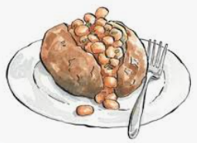 |  | 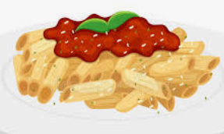 | 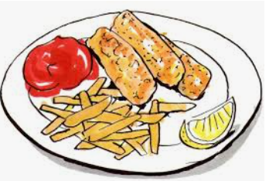

FACE MASKS
Please can all parents ensure that face masks are worn at all times whilst on the school premises. Thank you for your cooperation!

STAGGERED START AND PICK-UP TIMES
Please see below for your child’s drop and pick-up times

Year Group | Arrival Time | Pick up time | Door
Nursery | 9:00am – 9:15am | 2:55pm | Enter and exit through usual EYFS entrance.
Reception | 8:45am – 9:00am | 3:10pm | Enter and exit through usual EYFS entrance.
Year One | 8.45am – 9:00am | 3:00pm | Enter and exit through classroom doors
Year Two | 8:45am – 9:00am | 3:00pm | KS1 Door
Year Three | 8:40am – 9:00am | 3:15pm | Enter and exit through classroom doors
Year Four | 8.40 - 9.00am | 3.10pm | Enter and exit through classroom doors
Year Five | 8.40am -9.00am | 3.15pm | Enter and exit through classroom doors
Year Six | 8.40am -9.00am | 3.15pm | Enter and exit through the KS2 hall.

CROSSACRES TERM DATES FOR 2021/22
Term dates for the 2021/22 academic year are detailed overleaf.

