Spring Has Sprung
Summer 1 -Reception

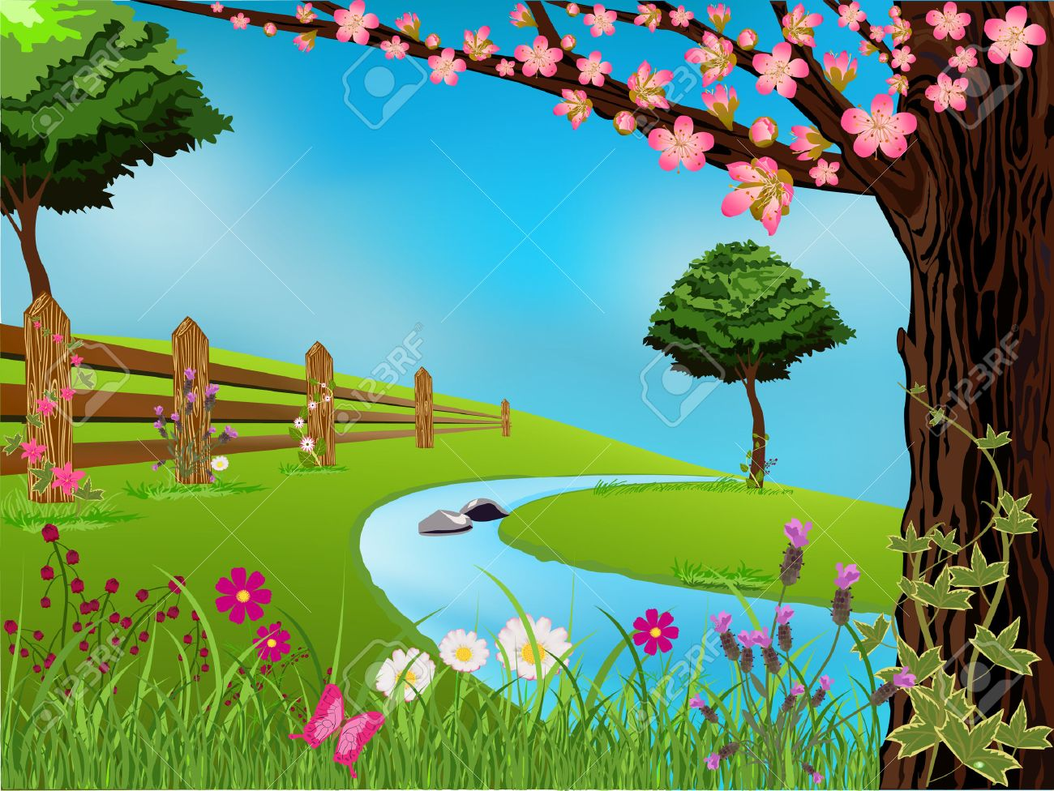
Literacy
Pupils will be taught to:
Discuss the lifecycle of plants through fiction using the Christopher Nibble story
Design a lost and found poster using Christopher’s Caterpillars story
Identify features of non fiction using Things with Wings text
Make a list of animals with wings, tails and claws.
Create their own non-fiction book about different animals.
Write their own question cards relating to animals with wings
Letter writing to Christopher
Instructions on how to look after pets with wings.

Personal, Social & Emotional Development
Pupils will be taught to:
Make and develop their own relationships within the classroom setting
Listen and take account of others ideas in conversations during circle times
Care for minibeasts
Feel confident when speaking in a familiar group, for example during show and tell
Work as part of a group or team and understand and follow the rules such as when with the sports coach

Celebrations
Ramadan – May 6th
World Cultural Diversity Day – 21st May

World day for cultural diversity –May 21st

Understanding the World
Pupils will be taught to:
Use all senses to investigate mini beast /small creature’s lifecycles,
Understand the importance of flowers to mini beasts,
Investigate the natural environment,
Create 3D models/clay models of mini beasts,
Explore and investigate habitats, for example go on a mini beast hunt
Select and use technology to record their findings
Explore different cultures via World day for cultural diversity – food tasting, music from around the world.
Discuss their observations after watching selected DVD clips about animals with wings.

Mathematics
Pupils will be taught to:
Order two or three items by length or height.
Use familiar objects and shapes to create and recreate patterns.
Make symmetrical patterns for wings (doubling/halving)
Make their own sandwich (doubling/halving)
Count in 2s and 10s
Use everyday language in relation to money (paying for snack)

Physical Development
Pupils will be taught to:
Develop their ball skills – such as throwing, catching, balancing, rolling and kicking.
Discuss and understand the importance of a healthy diet, physical exercise and keeping safe
Develop their upper body strength by accessing all areas of the climbing frame such as moving in, over and through competently
Work as a team when using their skills during Sports Day
Consolidate their coordination in large and small movements when working with the sports coach
Handle equipment and tools, including pencils, effectively for writing

Communication & Language
Pupils will be taught to:
Match pictures of animals to the related caption and discuss.
Sort, describe or narrate information about a chosen animal.
Follow a story without pictures or props.
Follow instructions involving several ideas or actions within the classroom.
Anticipate key parts of a story and respond with relevant comments, questions or actions.
Develop their own stories by connecting ideas or events.
Expressive Arts & Design
Pupils will be taught to:
Make mini beasts with egg cartons, clay, pom-poms.
Butterfly symmetrical paintings (XC Numeracy)
Join materials they are using in a variety of ways.
Explore different sounds of instruments.
Play cooperatively as part of a group to develop and act out a story.
Represent their own ideas through art, music, dance and role play.

