Vocabulary, Grammar and Punctuation Appendix
Year 6
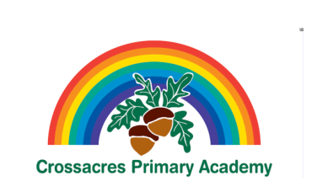

This document contains the Y6 Vocabulary, Grammar and Punctuation appendix and should be used to support the planning, teaching and learning of Spelling in Year 6.

Year 6: Detail of content to be introduced (statutory requirement)
Word | The difference between vocabulary typical of informal speech and vocabulary appropriate for formal speech and writing [for example, find out – discover; ask for – request; go in – enter]  How words are related by meaning as synonyms and antonyms [for example, big, large, little].
Sentence | Use of the passive to affect the presentation of information in a sentence [for example, I broke the window in the greenhouse versus The window in the greenhouse was broken (by me)].  The difference between structures typical of informal speech and structures appropriate for formal speech and writing [for example, the use of question tags: He’s your friend, isn’t he?, or the use of subjunctive forms such as If I were or Were they to come in some very formal writing and speech]
Text | Linking ideas across paragraphs using a wider range of cohesive devices: repetition of a word or phrase, grammatical connections [for example, the use of adverbials such as on the other hand, in contrast, or as a consequence], and ellipsis  Layout devices [for example, headings, sub-headings, columns, bullets, or tables, to structure text]
Punctuation | Use of the semi-colon, colon and dash to mark the boundary between independent clauses [for example, It’s raining; I’m fed up]  Use of the colon to introduce a list and use of semi-colons within lists  Punctuation of bullet points to list information  How hyphens can be used to avoid ambiguity [for example, man eating shark versus man-eating shark, or recover versus re-cover]
Terminology for pupils | subject, object  active, passive  synonym, antonym  ellipsis, hyphen, colon, semi-colon, bullet points

