Vocabulary, Grammar and Punctuation Appendix
Year 4
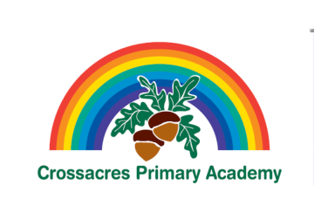

This document contains the Y4 Vocabulary, Grammar and Punctuation appendix and should be used to support the planning, teaching and learning of Spelling in Year 4.

Year 4: Detail of content to be introduced (statutory requirement)
Word | The grammatical difference between plural and possessive –s  Standard English forms for verb inflections instead of local spoken forms [for example, we were instead of we was, or I did instead of I done]
Sentence | Noun phrases expanded by the addition of modifying adjectives, nouns and preposition phrases (e.g. the teacher expanded to: the strict maths teacher with curly hair)  Fronted adverbials [for example, Later that day, I heard the bad news.]
Text | Use of paragraphs to organise ideas around a theme  Appropriate choice of pronoun or noun within and across sentences to aid cohesion and avoid repetition
Punctuation | Use of inverted commas and other punctuation to indicate direct speech [for example, a comma after the reporting clause; end punctuation within inverted commas: The conductor shouted, “Sit down!”]  Apostrophes to mark plural possession [for example, the girl’s name, the girls’ names]  Use of commas after fronted adverbials
Terminology for pupils | determiner  pronoun, possessive pronoun  adverbial

