Vocabulary, Grammar and Punctuation Appendix
Year 2
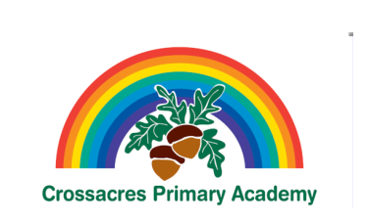

This document contains the Y2 Vocabulary, Grammar and Punctuation appendix and should be used to support the planning, teaching and learning of Spelling in Year 2.

Year 2: Detail of content to be introduced (statutory requirement)
Word | Formation of nouns using suffixes such as –ness, –er and by compounding [for example, whiteboard, superman]  Formation of adjectives using suffixes such as –ful, –less  (A fuller list of suffixes can be found on page Error! Bookmark not defined. in the year 2 spelling section in English Appendix 1)  Use of the suffixes –er, –est in adjectives and the use of –ly in Standard English to turn adjectives into adverbs
Sentence | Subordination (using when, if, that, because) and co-ordination (using or, and, but)  Expanded noun phrases for description and specification [for example, the blue butterfly, plain flour, the man in the moon]  How the grammatical patterns in a sentence indicate its function as a statement, question, exclamation or command
Text | Correct choice and consistent use of present tense and past tense throughout writing  Use of the progressive form of verbs in the present and past tense to mark actions in progress [for example, she is drumming, he was shouting]
Punctuation | Use of capital letters, full stops, question marks and exclamation marks to demarcate sentences  Commas to separate items in a list  Apostrophes to mark where letters are missing in spelling and to mark singular possession in nouns [for example, the girl’s name]
Terminology for pupils | noun, noun phrase  statement, question, exclamation, command  compound, suffix  adjective, adverb, verb  tense (past, present)  apostrophe, comma

