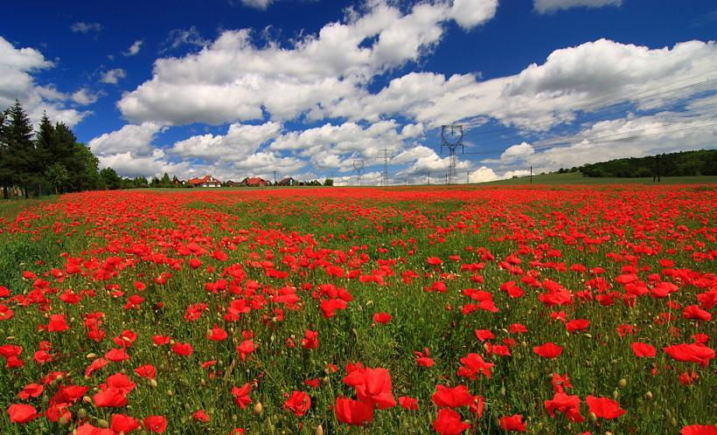

English

Non-chronological report

Stories with Flashbacks

Stories with a Fantasy Setting

Subjunctive Poetry

History

## A study of an aspect or theme in British history that extends pupils’ chronological knowledge beyond 1066

Additional information:

I can place features of historical events and people from the past societies and periods in a chronological framework.

I can summarise how the First World War had a major effect on Britain.

I can use primary and secondary sources to find out about the past.

I can identify and explain propaganda.

I can describe the features of historical events and way of life from periods I have studied.

Art

Pastel piece based on official war artist Paul Nash

I can explain why I have used different tools to create art.

I can explain why I have chosen specific techniques to create my art.

I can explain the style of my work and how it has been influenced by a famous artist.

I can use feedback to make amendments and improvement to my art.

Maths 

See medium term plan

Computing

Design, write and debug programs that accomplish specific goals, including controlling or simulating physical systems; solve problems by decomposing them into smaller parts.

Use sequence, selection, and repetition in programs; work with variables and various forms of input and output.

Use logical reasoning to explain some simple algorithms and programs.

I know what a variable is

I can edit variables to change the outcome

I know what features make a good game

I can predict what a code will do

I can manipulate code to change the outcome

I can code creatively

I know that different shapes represent different instructions within a flowchart

I can create a flowchart to program a robot

I can use selection (if…then) within my flowchart

I can trace a flowchart in order to debug it

I can write a program that will meet a specific objective

Shared Reading

The Nowhere Emporium

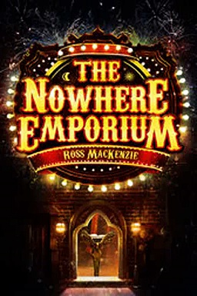

Grammar

Passive and Active Voice

Subjunctive

Present Perfect

Past Progressive

Modal Verbs

Determiners

Music

Manchester scheme of work

PSHE

Getting on and falling out

**SMSC**

Democracy

PE

Manchester City Sports Coach

French

Module 2 Niveau Tricolore

Autumn 2

The Great War

Science: Animals including Humans

Identify and name the main parts of the human circulatory system, and describe the functions of the heart, blood vessels and blood.

Recognise the impact of diet, exercise, drugs and lifestyle on the way their bodies function

Describe the way in which nutrients and water are transported within animals, including humans.

Describe the functions of the heart, blood vessels and blood.