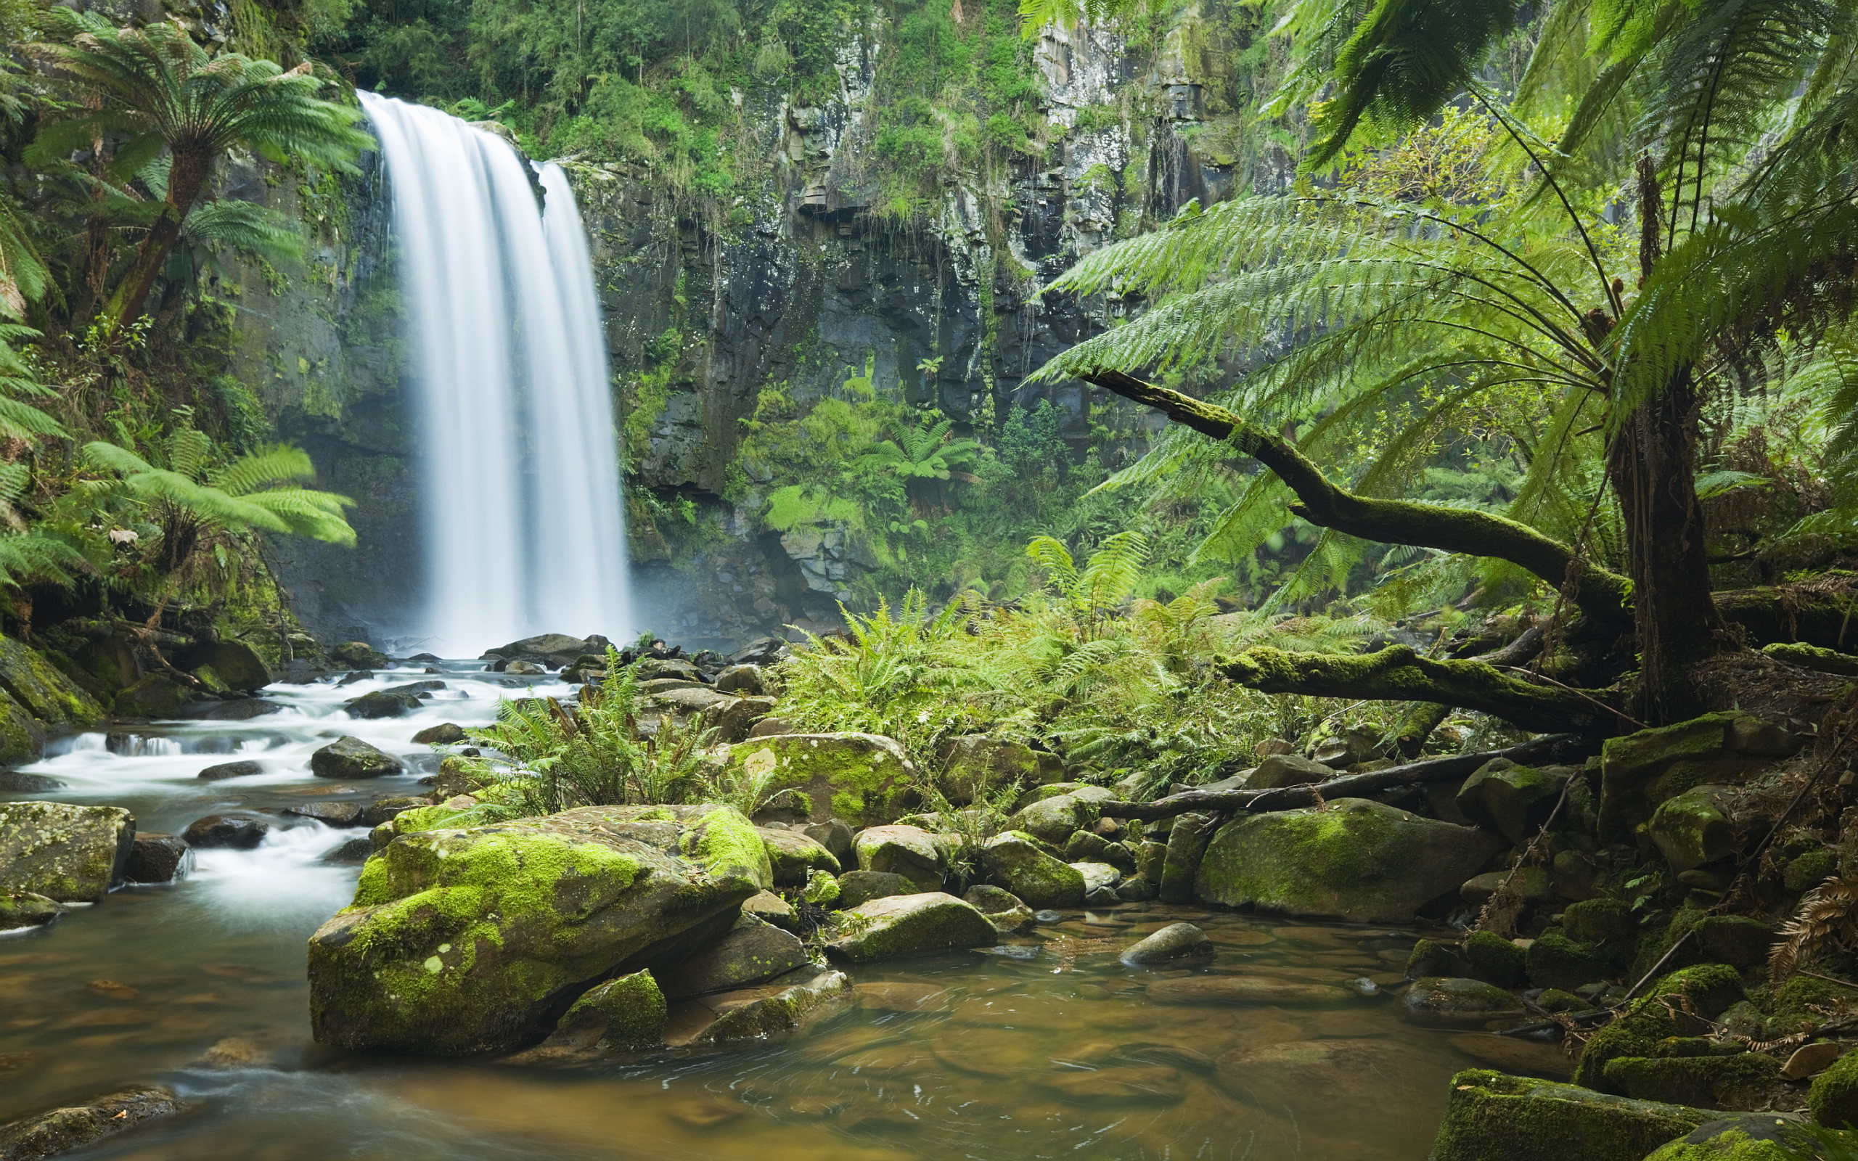

Spring 2 Amazin’ Amazon

Computing - Writing Code

design, write and debug programs that accomplish specific goals, including controlling or simulating physical systems; solve problems by decomposing them into smaller parts.

use logical reasoning to explain how some simple algorithms work and to detect and correct errors in algorithms and programs

### Enrichment – Ghyll Head residential trip. Ghylucation –

### Religious Ed – What do religions say to us when life gets hard ? ucation –

Grammar

Passive and Active Voice

Subjunctive

Present Perfect

Past Progressive

Modal Verbs

Determiners

PSHE

Getting on and falling out

PE

Manchester City sports coach

English

Subjunctive Poetry

Balanced Argument

Writing in Role

Narrative

Newspaper Reports

Maths

Measurements

Number Operations

Fractions

Music

Sounds of the Amazon

Geography

TASC: To write a news report for a website about the environmental and economic issues facing the rainforest

Human geography, including types of settlement and land use, economic activity including trade links, and the distribution of natural resources including energy, food , minerals and water.

Additional information:

* Rainforest natural resources
* Deforestation and its effects
* Conflicts of interest: farming, logging, loss of habitat, tribal villages
* Push and pull factors for migration

Science: Living things and their habitats

TASC: To classify and compare animals and plants between our locality and the Amazon rainforest

Describe how living things are classified into broad groups according to common observable characteristics and based on similarities and differences, including micro-organisms, plants and animals.

Give reasons for classifying plants and animals based on specific characteristics.

Art

TASC: To create an Amazon village house using clay

To create sketch books to record their observations and use them to review and revisit ideas

To improve their mastery of art and design techniques, including drawing, painting and sculpture with a range of materials.

Additional information:

* Study of various houses/dwellings – sketch
* Break down house sketches into flat sections (roof, walls)
* Learn techniques: rolling clay with no air bubbles, making slip, joining sides securely