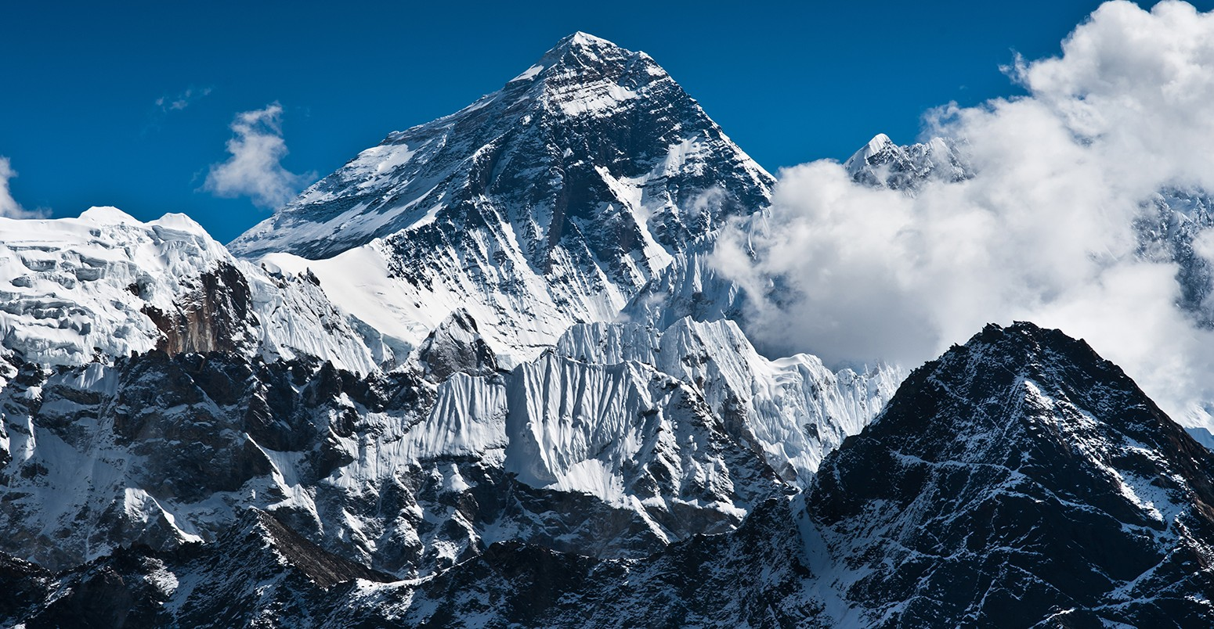

Science

Pupils will be taught to:

* Recognise that living things have changed over time and that fossils provide information about living things that inhabited the Earth millions of years ago.
* Recognise that living things produce offspring of the same kind, but normally offspring vary and are not identical to their parents.
* Identify how plants and animals are adapted to suit their environment in different ways and that adaptation may lead to evolution.

Mathematics

Pupils will be taught to:

* Find percentages of numbers.
* Compare quantities using ratio.
* Describe a pattern algebraically.
* Write and evaluate algebraic expressions.
* Calculate the area and perimeter or parallelograms .and triangles.
* Find the volume of cubes and cuboids.

DT –

Pupils will be taught to:

Generating ideas:

Generate, develop, model and communicate their ideas through discussion.

Making:

Select from and use a wider range of materials and components, including construction materials, textiles and ingredients, according to their functional properties and aesthetic qualities.

Annotated sketches, cross-sectional and exploded diagrams, prototypes, pattern pieces and computer aided design.

Evaluating

Investigate and analyse a range of existing products.

Knowledge:

Apply their understanding of how to strengthen, stiffen and reinforce more complex structures.

### Religious Education –

### Pupils will be taught to:

Knowing and Understanding:

Discuss what matters most to Christians and humanists.

Express and Communicate:

Describe what Christians mean about humans being made in the image of God and being ‘fallen’, giving examples.

Describe some Christian and Humanist values simply.

Gain and Deploy Skills:

|  |
| --- |
| Express their own ideas about some big moral concepts, such as fairness or honesty comparing them with the ideas of others they have studied.  Suggest reasons why it might be helpful to follow a moral code and why it might be difficult, offering different points of view. |

### Music – Charanga!

Pupils will be taught to:

Singing:

Sing in harmony confidently.

Playing:

Use a variety of different musical devices in their compositions.

Composing

Analyse features in different pieces of music.

Computing – Blogging

Pupils will be taught to:

*Access a blog site.

* Create content for a blog site using a number of different applications.

* Upload content in various forms

* Be aware of their audience whilst blogging.

* Write positive/constructive comments on other people’s blogs.

PE – Gymnastics

Pupils will be taught to:

Make complex, extended sequences.

Combine action, balance and shape.

Perform consistently to different audiences.

English

Pupils will be taught to:

|  |  |
| --- | --- |
| Writing  Non-chronological report  -Write a leaflet about Ghyll Head  Informal letter  - Write an email about conquering Everest  Instructions  -Write a set of instructions to climb Everest  Persuasive text  - Write an advert for a tent | Grammar & Spelling  Colons and semi colons  Modal verbs  Statements, questions and commands  Standard and non-Standard English  Punctuation for parenthesis  Spelling Patterns:  Prefix dis-, im-, over-, un  /f/ spelled ph  Words with origins in other countries  Words with unstressed vowel sounds  Words ending /shuhl/ after a vowel  Words ending /shuhl/ after a consonant |
| Reading:  *Shared Reading Texts/ Class Novel*  Boy in the Tower  Content Domains  2a give / explain the meaning of words in context  2b retrieve and record information / identify key details from fiction and non-fiction  2c summarise main ideas from more than one paragraph  2d make inferences from the text / explain and justify inferences with evidence from the text  2e predict what might happen from details stated and implied  2f identify / explain how information / narrative content is related and contributes to meaning as a whole  2g identify / explain how meaning is enhanced through choice of words and phrases  2h make comparisons within the text | |

Geography – Mountain Regions

Pupils will be taught to:

World Knowledge

Name and locate many of the world's most famous mountainous regions in an atlas.

Geographical Enquiry:

Answer questions by using a map.

Human and Physical

Explain why people are attracted to visit mountainous areas.

Year 6 Spring 1

Born Survivor