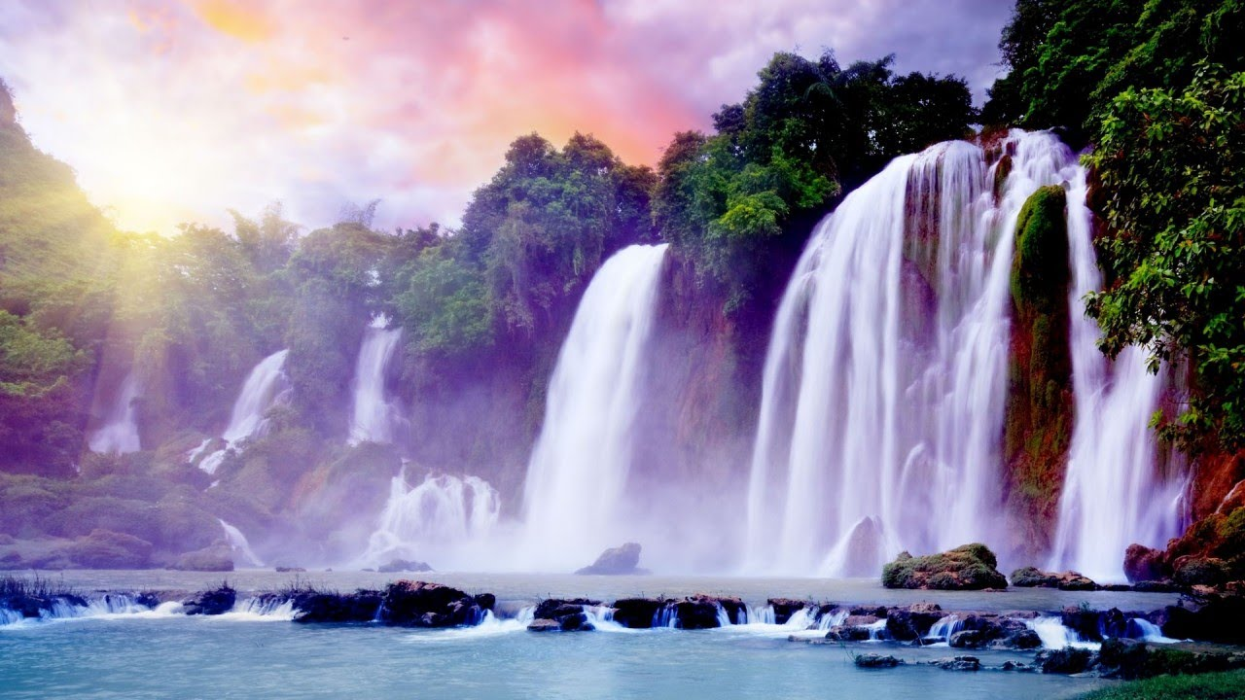

**English**

* Poetry based on water (1 week)
* Narrative (Kensuke’s Kingdom) (2 weeks)
* Persuasive Writing (2 weeks)
* Diary (Kensuke’s Kingdom) (2 weeks)

Grammar- To focus on a variety of concepts including punctuation, grammar and spelling.

### **Computing**

**E-safety**

* Use technology safely, respectfully and responsibly; recognize acceptable/unacceptable behaviour; identify a range of ways to report concerns about content and contact

Additional information:

* Looking at variety of scenarios related to staying safe on the internet.
* Case study of an E-Safety issue.
* Social Media
* SMART

I know what social networking is and am familiar with some social networking sites

I know you have to be 13 to open a Facebook account

I am aware of some of the implications of opening a Facebook account when underage

I can use a range of technologies and online services responsibly and know a range of ways to report concerns

I am able to consider appropriateness of information

I know to only accept friends that are true real life friends

I recognise ethical issues surrounding the application of information technology beyond the school

**PSHE**

New Beginnings

# **Science**

**TASC: To create a working water filter**

Properties and changes of materials

* Compare and group together everyday materials on the basis of their properties, including their hardness, solubility, transparency, conductivity (electrical and thermal), and response to magnets.
* Know that some materials will dissolve in liquid to form a solution, and describe how to recover a substance from a solution.
* Use knowledge of solids, liquids and gases to decide how mixtures might be separated, including through filtering, sieving and evaporating.
* Give reasons, based on evidence from comparative and fair tests of the particular uses of everyday materials including metals, wood and plastic.
* Demonstrate that dissolving, mixing and changes of state are reversible changes.
* Explain that some changes result in the formation of new materials, and that this kind of change is not usually reversible, including changes associated with burning and the action of acid on bicarbonate of soda.

Extended Writing – The Water Cycle.

#### 

**Enrichment**

Trip to Quarry Bank Mill.

IMPS Trip.

Airport Trip.

### **Religious Education**

Is it better to express your religion in arts and architecture or in charity and generosity?

## Additional information:

Describe and make connections between examples of religious creativity (buildings and art) (A1).

Notice, list and explain similarities and differences between different sacred buildings.

Notice, list and explain similarities and differences between Christian and Muslim sacred buildings.

Describe and make connections between examples of religious creativity in Muslim buildings

Describe why mosques matter to the Muslim community

**Maths**

See medium term plan

**Geography**

**TASC: To create a 3D model of a river basin**

Describe and understand key aspects of physical geography, including: rivers, mountains, and the water cycle.

Additional information:

I can identify different rivers of the world.

I can answer questions by using a map.

I can explain the course of a river.

I can name and locate many of the world's most famous mountainous regions in an atlas.

I can describe and explain the main uses of rivers.

### **French**

Modules 1-5

**Art and Design**

**TASC: To create individual and collaborative pieces of art, based around the work of Hokusai.**

To improve mastery of art and design techniques, including, drawing and painting with a range of materials.

Additional Information

* To sketch and draw different aspects of rivers in pencil, charcoal and water colours.
* To evaluate and discuss their work in order improve their own skills.
* To evaluate other artists’ work and use to inspire their own art.

Water, Water Everywhere

Year 6

Autumn 1

**Music** – Children are to create their own music based round the flow and movement of a river.

## **P.E.**

### Outdoor games (Manchester City) and gym