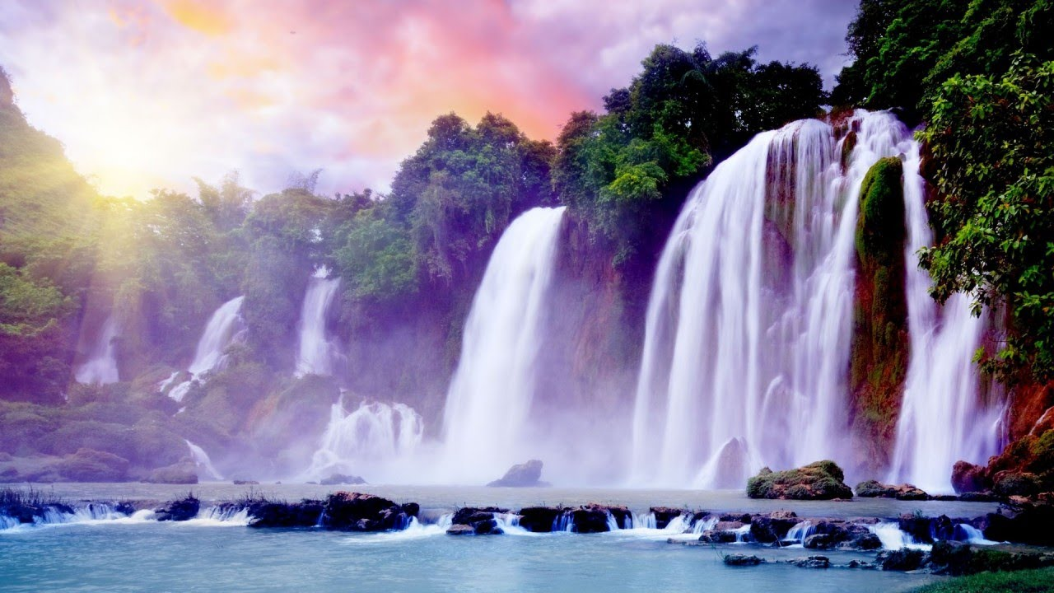

### **Computing**

**TASC: To create a display of advice on an E-Safety scenario (link to English)**

* Use technology safely, respectfully and responsibly; recognize acceptable/unacceptable behaviour; identify a range of ways to report concerns about content and contact

Additional information:

* Looking at variety of scenarios related to staying safe on the internet.
* Case study of an E-Safety issue.
* Social Media
* SMART

# **Science**

**TASC: To create a working water filter**

Properties and changes of materials

* Compare and group together everyday materials on the basis of their properties, including their hardness, solubility, transparency, conductivity (electrical and thermal), and response to magnets.
* Know that some materials will dissolve in liquid to form a solution, and describe how to recover a substance from a solution.
* Use knowledge of solids, liquids and gases to decide how mixtures might be separated, including through filtering, sieving and evaporating.
* Give reasons, based on evidence from comparative and fair tests of the particular uses of everyday materials including metals, wood and plastic.
* Demonstrate that dissolving, mixing and changes of state are reversible changes.
* Explain that some changes result in the formation of new materials, and that this kind of change is not usually reversible, including changes associated with burning and the action of acid on bicarbonate of soda.

Extended Writing – The Water Cycle.

#### 

**PSHE/ SMSC**

Democracy

Rights and Responsibilities – Freedom!

Our Interconnected World

**Art and Design**

**TASC: To create individual and collaborative pieces of art, based around the work of Hokusai.**

To improve mastery of art and design techniques, including, drawing and painting with a range of materials.

Additional Information

* To sketch and draw different aspects of rivers in pencil, charcoal and water colours.
* To evaluate and discuss their work in order improve their own skills.
* To evaluate other artists’ work and use to inspire their own art.

**Geography**

**TASC: To create a 3D model of a river basin**

Describe and understand key aspects of physical geography, including: rivers, mountains, and the water cycle.

Additional information:

* To understand features of a river and how they are formed.
* To plot rivers of the world and rivers in England onto a map.
* To understand the correlation between the water cycles and rivers (link to Science)
* To investigate different rivers and focus on one to research – ie. Length, width, location, local wildlife.
* To understand how different places use rivers for different purposes.
* To draw and map a local river study and develop a field work investigation (based on Quarry Bank Mill).

Extended Writing – Ocean Maker – Contrastiong Settings. Information Text – QBM.

**Enrichment**

Trip to Quarry Bank Mill.

IMPS Trip.

Airport Trip.

Water, Water Everywhere

Year 6

Autumn 1

### **Religious Education**

**What do religions say to us when life gets hard?**

## -What questions have you got about what happens when we die?

- What do some people think carrieson after we have died? What is our soul?

- Do some people believe that you come back to life as a different thing? What is reincarnation?

- Do you get to heaven if you do things wrong?

- What do Christians think happens when we die?

- What do people who don’t believe in God think happens when we die?

- What different ideas are there about what happens when we die? What do I think?

**English**

* Poetry based on water (1 week)
* Narrative (Kensuke’s Kingdom) (2 weeks)
* Persuasive Writing (2 weeks)
* Diary (Kensuke’s Kingdom) (2 weeks)

Grammar- To focus on a variety of concepts including punctuation, grammar and spelling.

**Music** – Children are to create their own music based round the flow and movement of a river.

## **P.E.**

### Outdoor games (Manchester City) and gym

**Maths**

See medium term plan