CROSSACRES NEWSLETTER
11th January 2019
Welcome Back
Its great to see all the children back after the Christmas holidays. We hope everyone had a lovely break
QUADS / DINING ROOM
The New Year was welcomed in with the opening of our new KS2 dining room and the outdoor Quads for outdoor play provision. The children have really enjoyed the new environment and they have improved the overall look of the school.
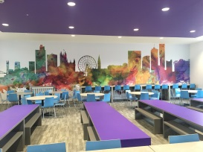
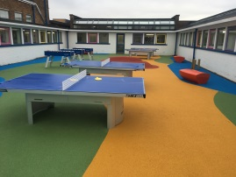

REPORTING ABSENCES
Please remember when reporting your childs absence to select option 1 on the telephone system. This option will take you straight through to the Attendance Officers absence line. Thank you
AFTER SCHOOL CLUBS
After school clubs start back on Tuesday 15TH January. Letters have been sent out inviting pupils to clubs and the timetable is being circulated with pupils tonight.

DINNER MONEY
Please remember dinner money is to be paid each week on a Monday morning for the week ahead. The easiest way to pay for this is via the SIMS Agora system. If you need your log in details, please contact the school office.

REMINDERS

Trips
Year 3 – As part of their History topic on Romans, Year 3 will be visiting The Dewa Educational Centre in Chester on Thursday 17th January 2019. Please return your permission slip and voluntary contribution of £15 ASAP. Thank you.
Year 4 – As part of their ‘Living things in their habitats’ topic, Year 4 will be visiting Chester Zoo on Monday 28th January 2019. Please return your permission slip and voluntary contribution of £15 ASAP. Thank you.

CONTACT DETAILS
Please inform the Office if you have recently changed your contact details e.g. phone number and email contacts etc.

